12/10/2023

Brenda Beach & Jonathan Hardwick

Video Game Library & Sales

Video Game Library & Sales

User Manual

Contents

**Installation of Required Programs to Write Code** 2

**Installation of Python** 2

**Installation of Visual Studio Code** 8

**Download Website Code** 16

**Clone GitHub Repository CSC289** 16

**Download Website Code** 23

**Open the Project in Visual Studio Code and Activate the Virtual Environment** 30

**Install All Necessary Modules inside the Virtual Environment** 38

**Initialize the Website** 43

**Using the Website** 45

**Website Registration** 45

**Password Reset** 47

**Login to the Website** 49

**Select/Search for Specific Video Game** 50

**Creating a Video Game List on Account to Track Personal Collection** 51

**Admin Portal** 51

# **Installation of Required Programs to Write Code**

Currently, the Video Game Library and Sales program is not set to be run by an executable, so you will need to download and install a couple of programs if you do not already have them. Those programs are Python and Visual Studio Code. You can use a different IDE other than Visual Studio Code, but for this installation manual, we will be using Visual Studio Code.

## **Installation of Python**

1. The first thing you need to do to install Python onto your system is to go to the website <https://www.python.org>.

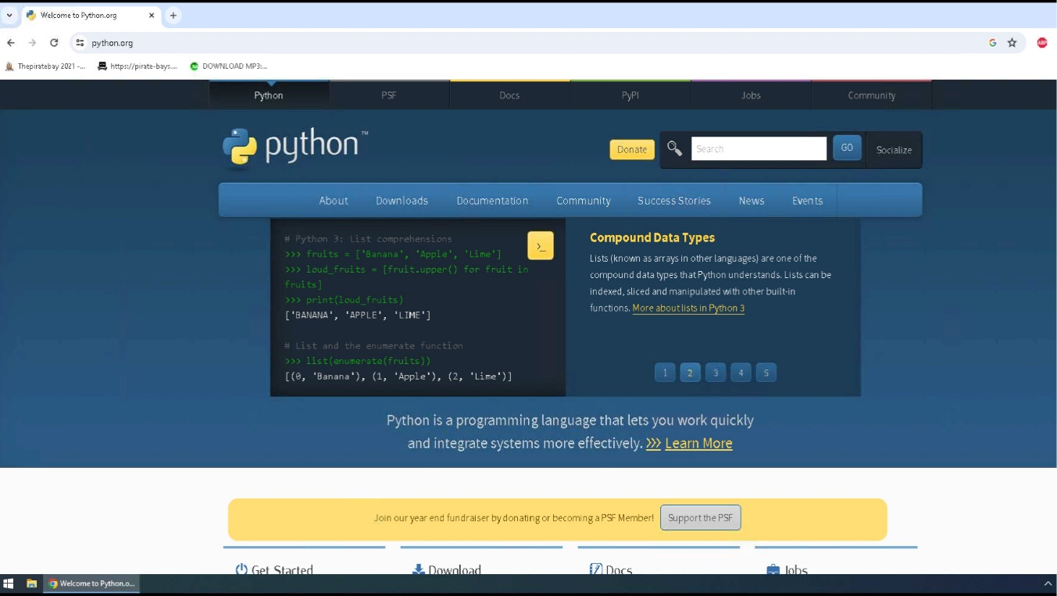

1. Once you have arrived at the website, you will click on the Downloads link and then click on the link to download the latest version of Python onto your system.

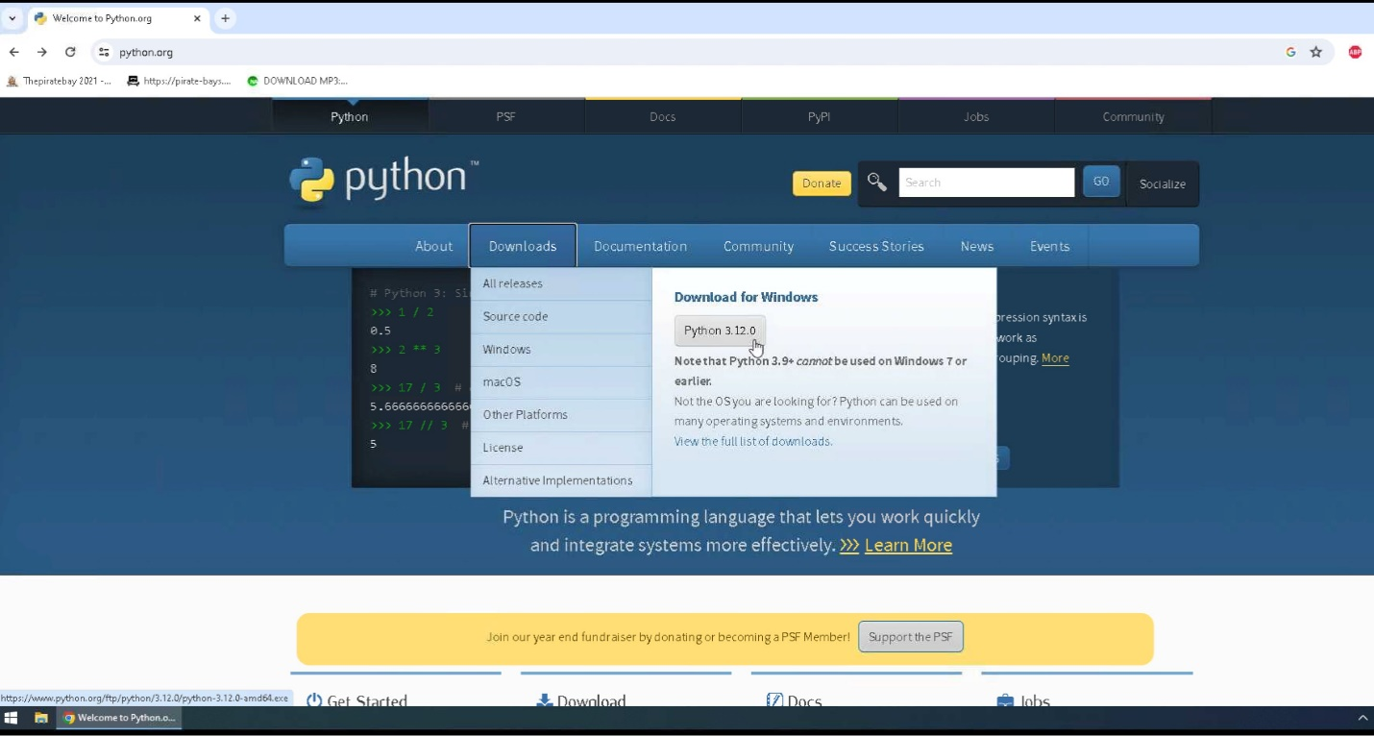

1. Python will download to your default downloads folder, and once it has been completed, you can click on the icon to view your downloaded file names in the upper right corner of your webpage so you can click on that file name and install the program onto your system.

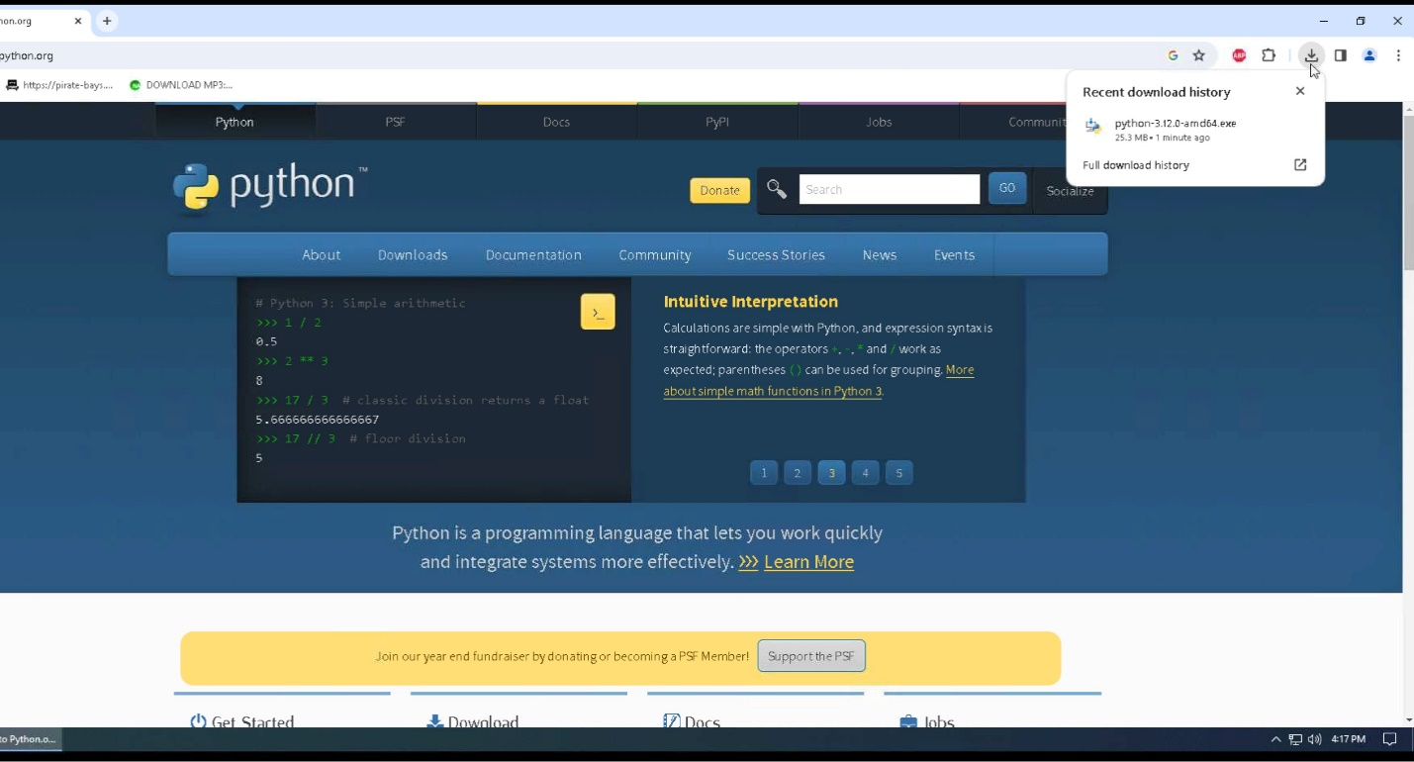

1. Click on run to install Python onto your system.

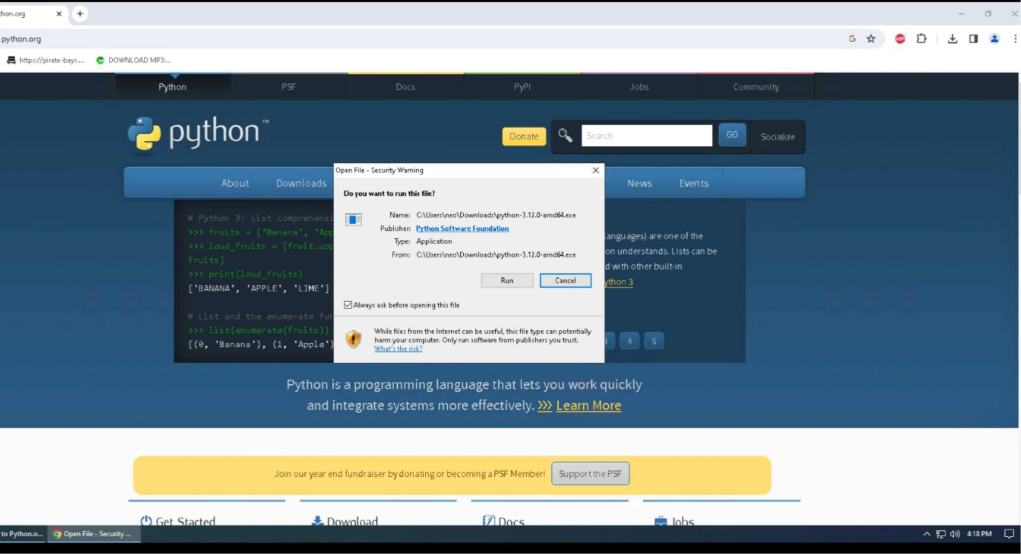

1. Click “Add Python to PATH,” then click Install Now.

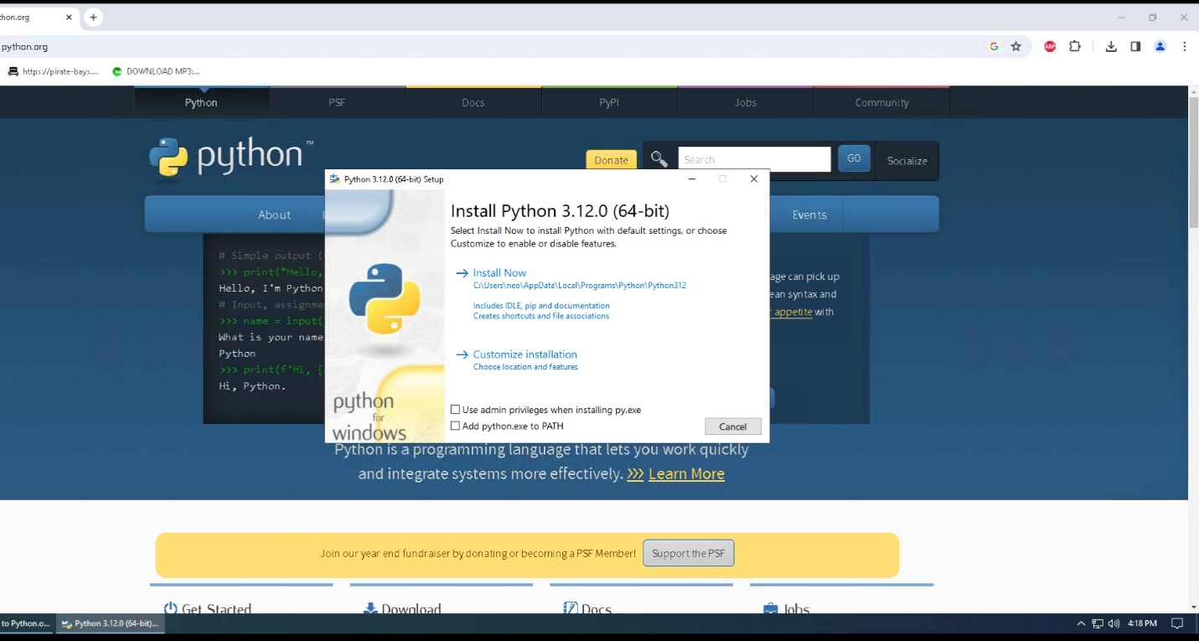

1. The program will now be installed on your system, and the status bar will show the progress level of the installation.

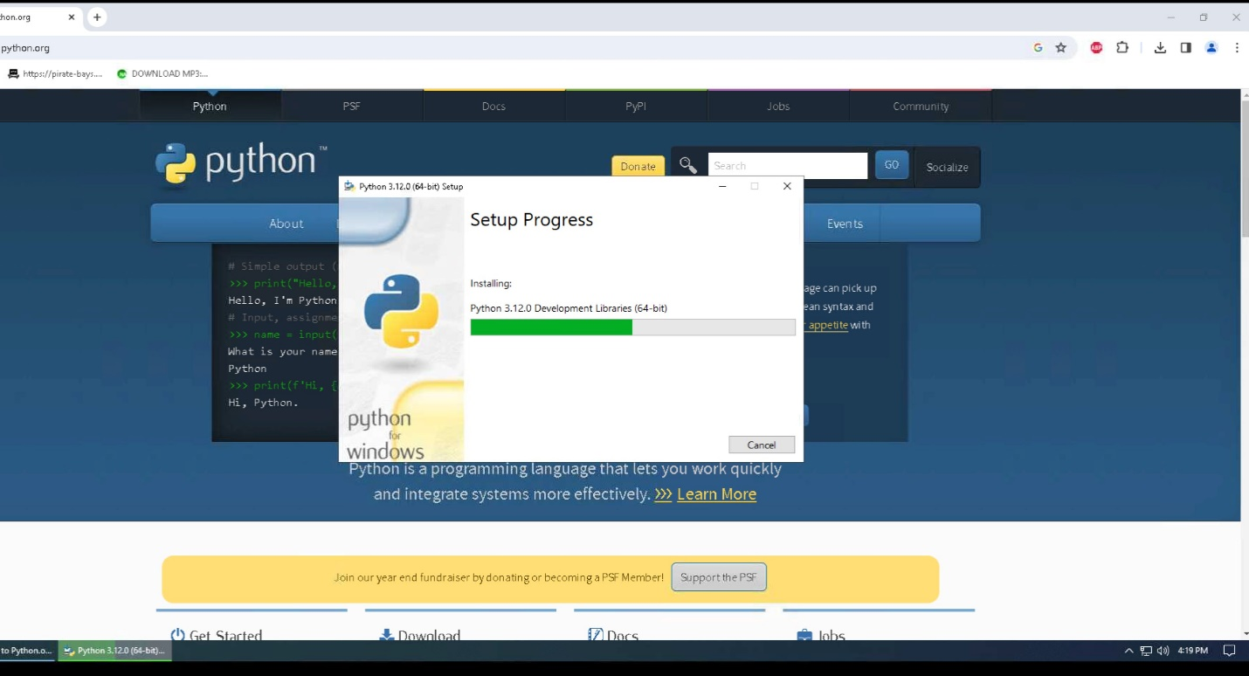

1. Once the installation is finished, click on Close to close the setup window. You can then close the web browser.

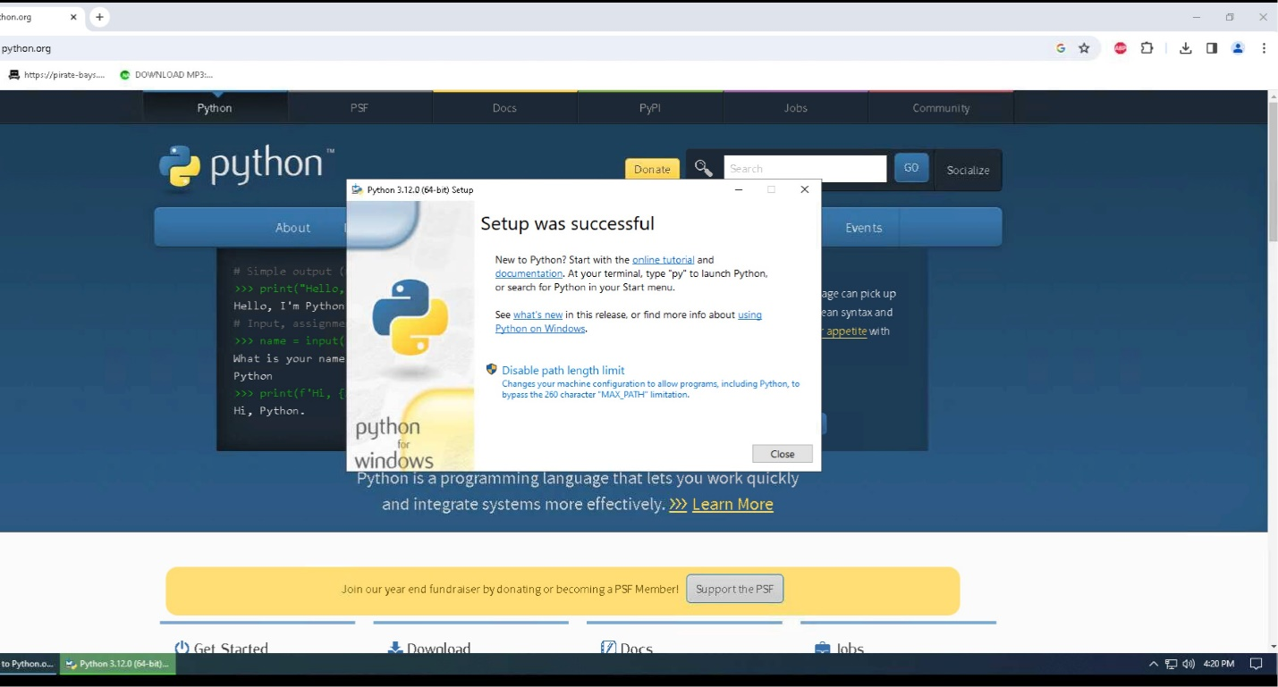

1. To verify the installation of Python onto your system, you can click on the Windows icon, also known as your start button, and under the recently added programs, you should see the Python program.

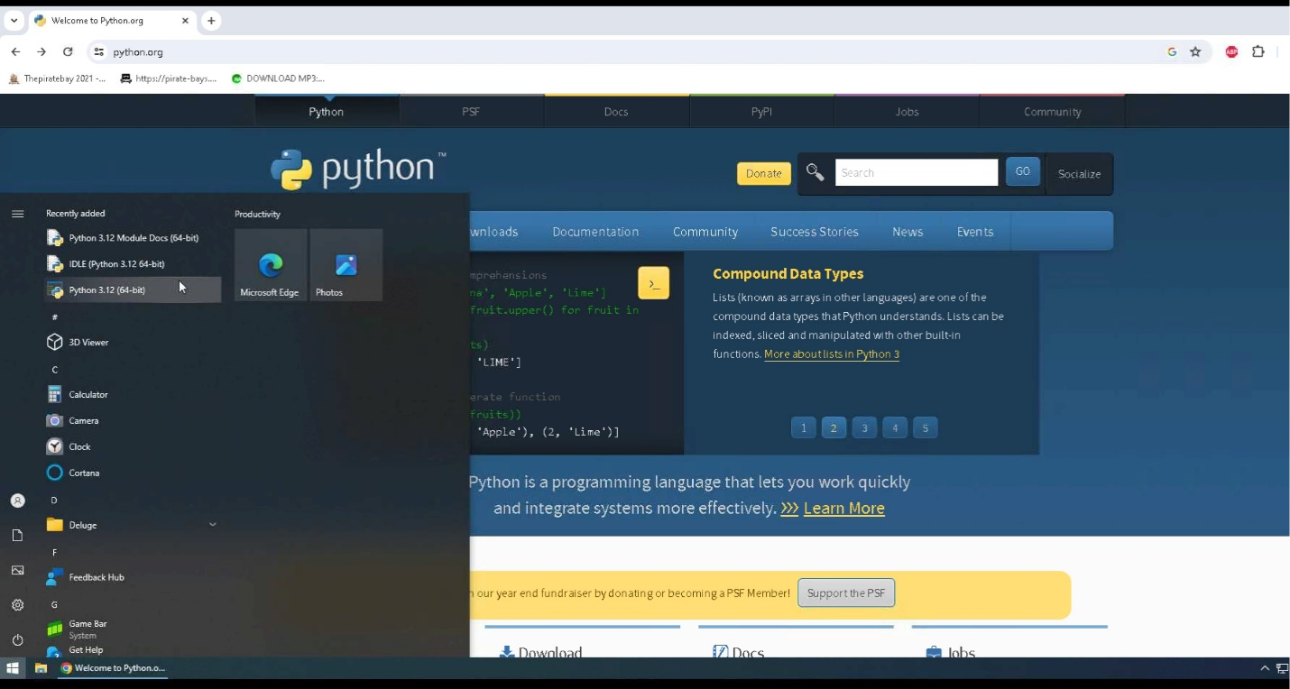

1. You can also verify that Python installed on your system by opening a command prompt (press the windows key and type cmd and select command prompt), and typing python –version. If you get an error message when you run this command, you must repeat these steps to reinstall Python on your system.

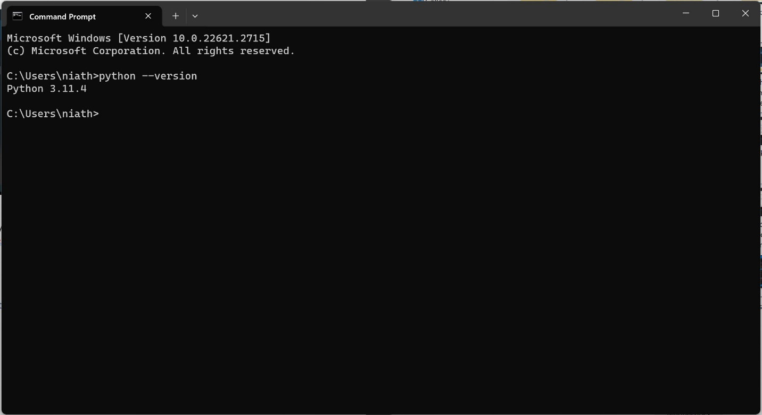

1. Now that Python is installed on your system, it is time to install our IDE so we can view our code and run the program.

## **Installation of Visual Studio Code**

1. To install Visual Studio Code, go to the webpage <https://code.visualstudio.com>.

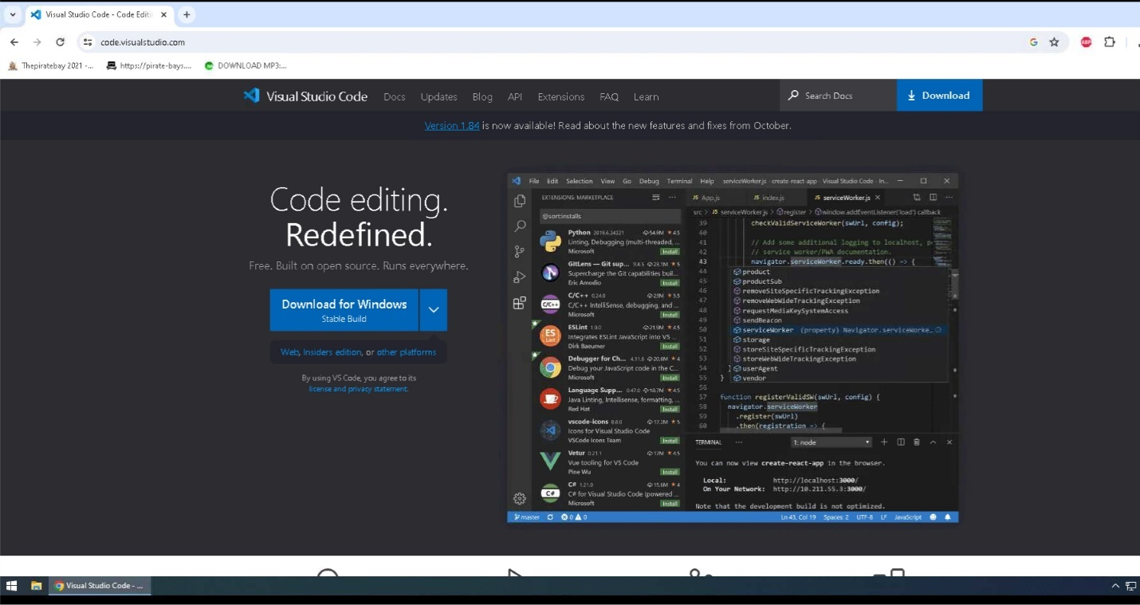

1. Click on download to download to your default downloads folder, and once it has been completed, you can click on the icon to view your downloaded file names in the upper right corner of your webpage.

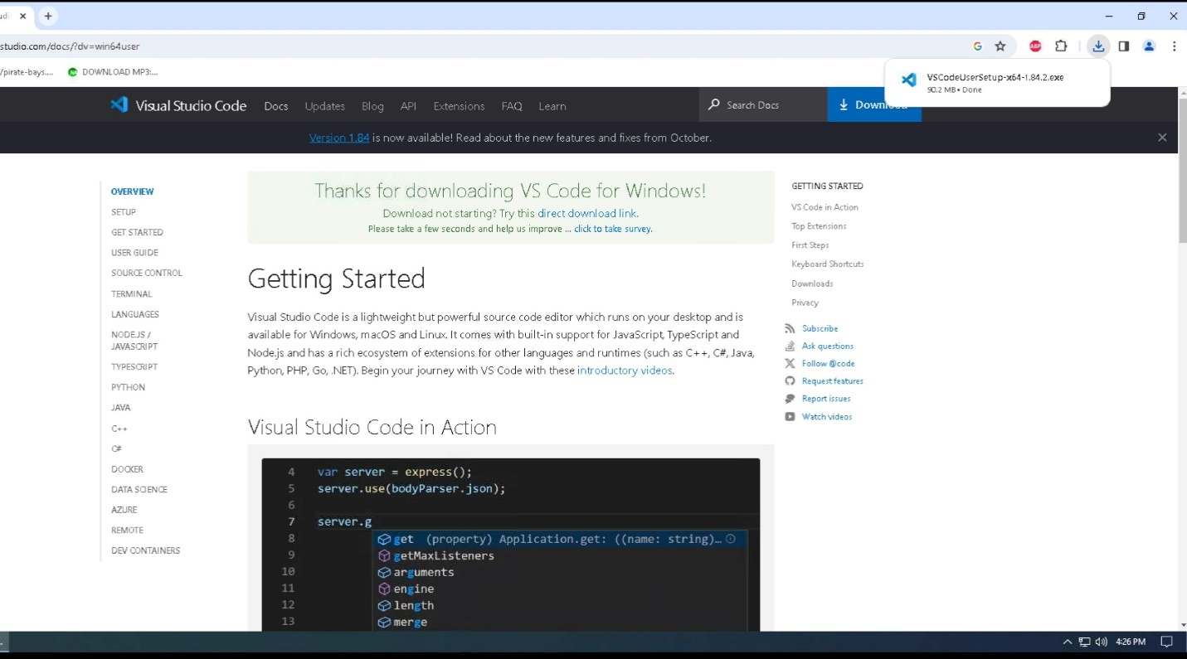

1. Click on the file name to install Visual Studio Code on your system.

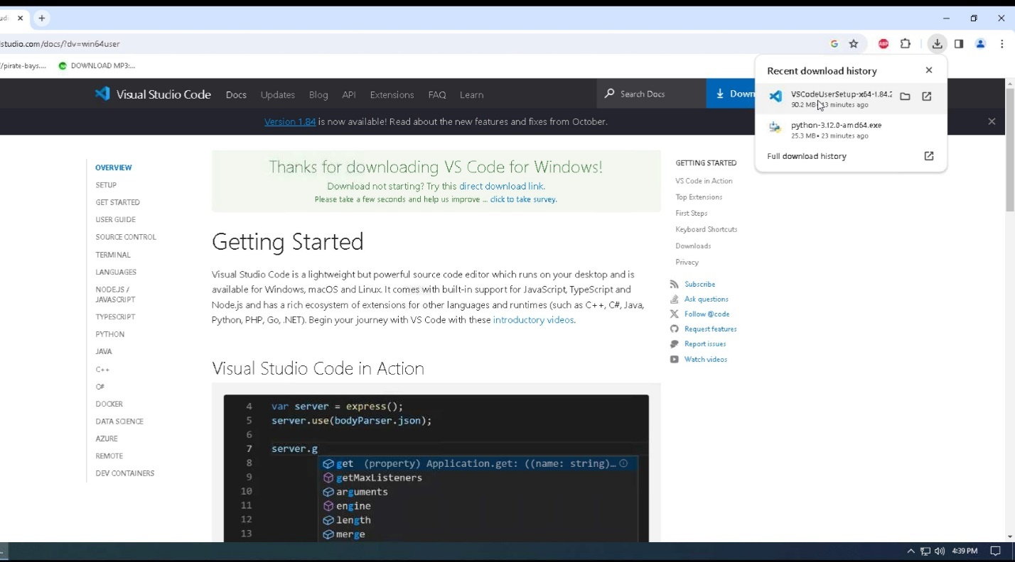

1. Click on Run to begin the installation of Visual Studio Code.

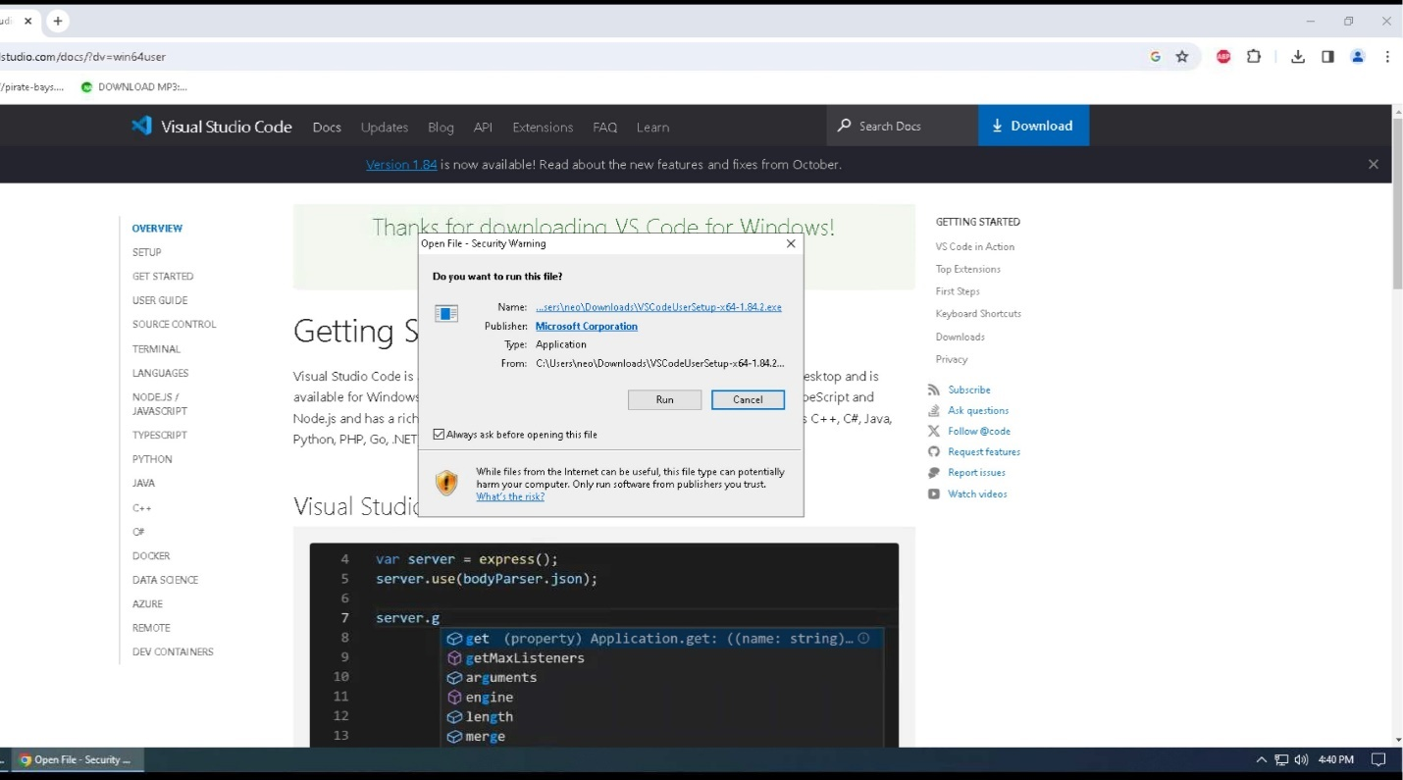

1. Select “I accept the agreement”, then click on Next.

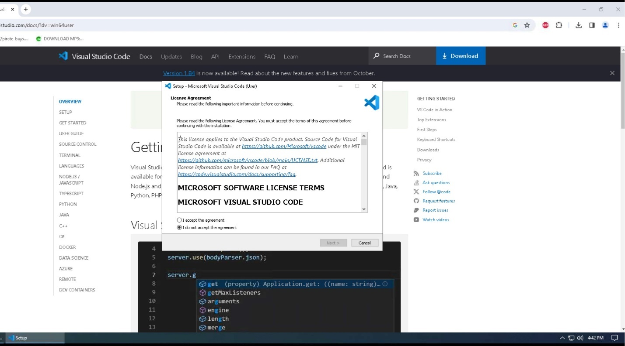

1. Click “Browse…” to select the location to install the program or leave it as the default location. Click Next to continue.

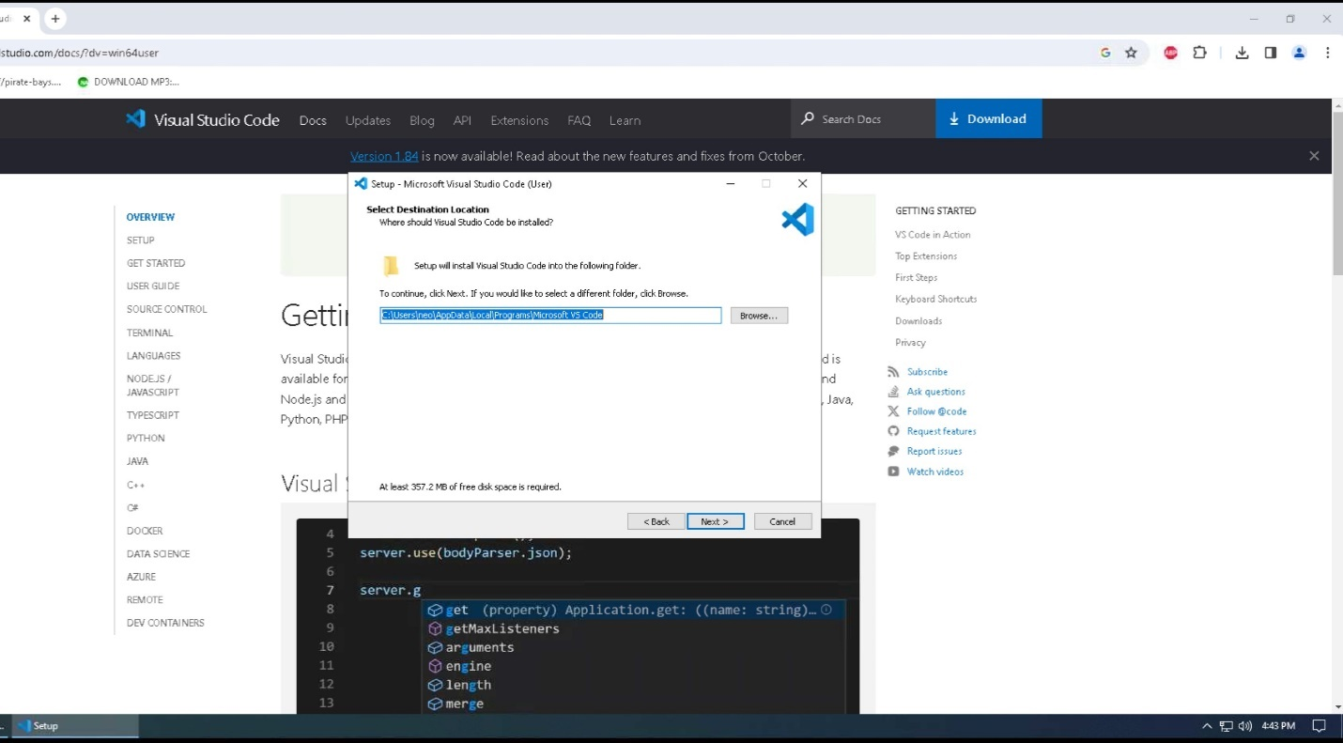

1. Click “Next” to accept the default location and continue to the next step in the installation process.

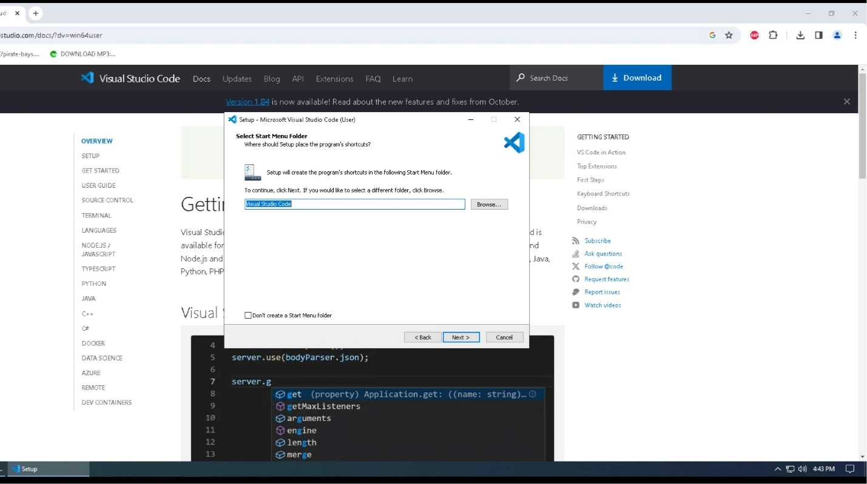

1. Click “Create Desktop Icon”, then click Next to continue to the next step of the installation process.

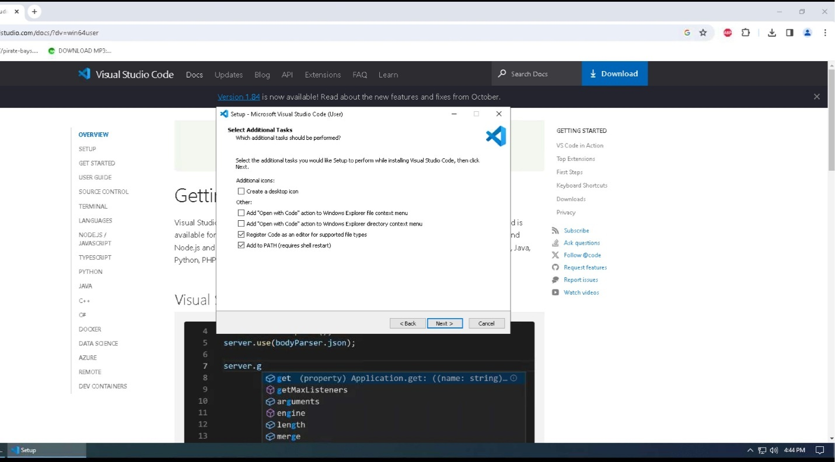

1. Click “Install” to install Visual Studio Code onto your system.

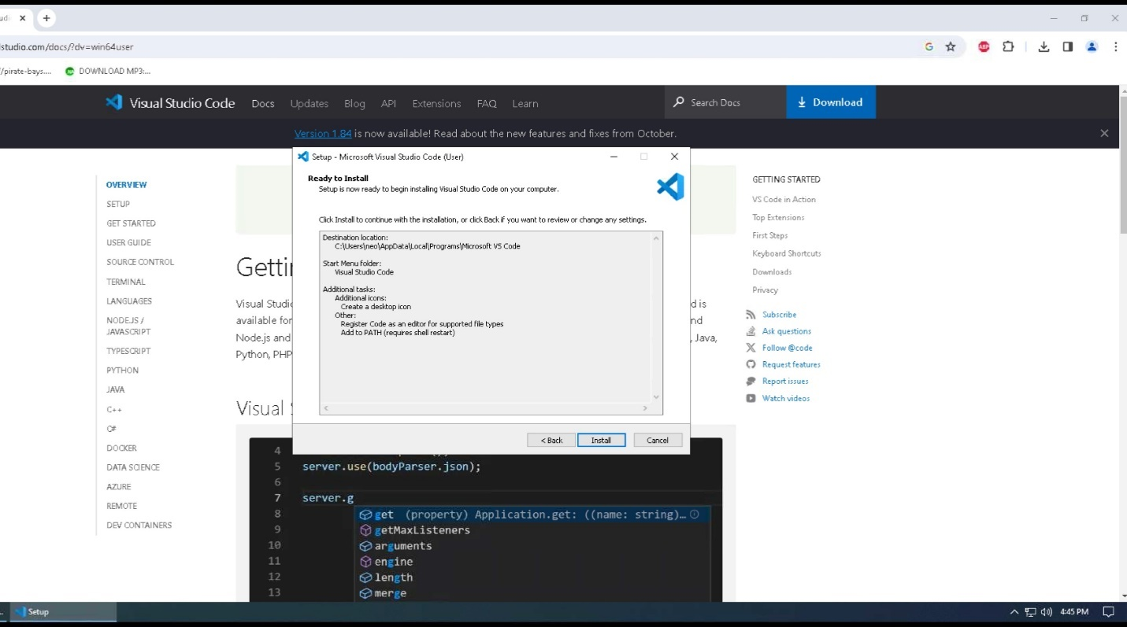

1. Visual Studio Code will now be installed on your system, and the status bar will show you the progress of that installation.

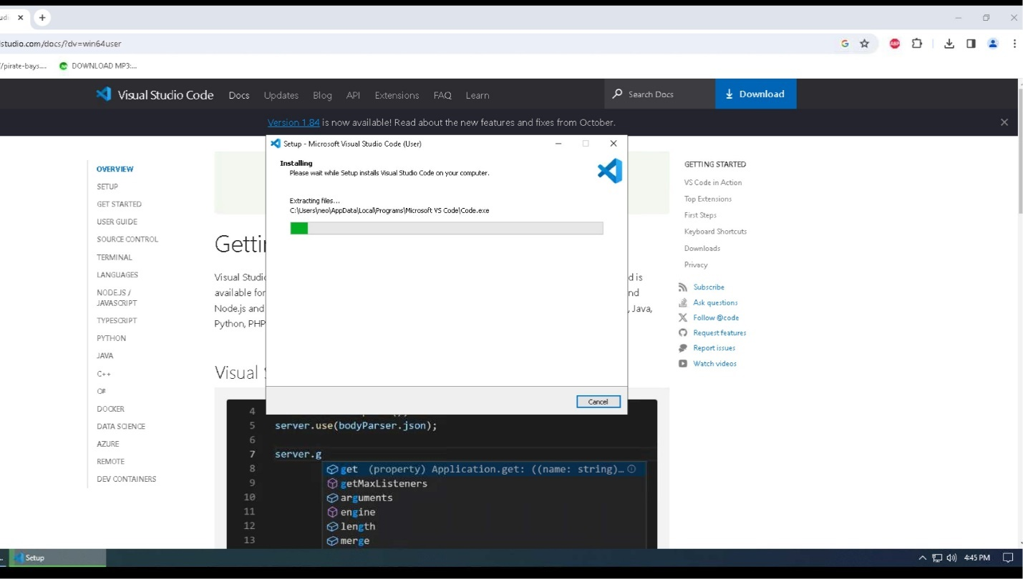

1. Once the program has been installed, ensure that the “Launch Visual Studio Code” is checked before you click “Finish”. This will close out the installation window and start the Visual Studio Code. You can also go ahead and close the web browser.

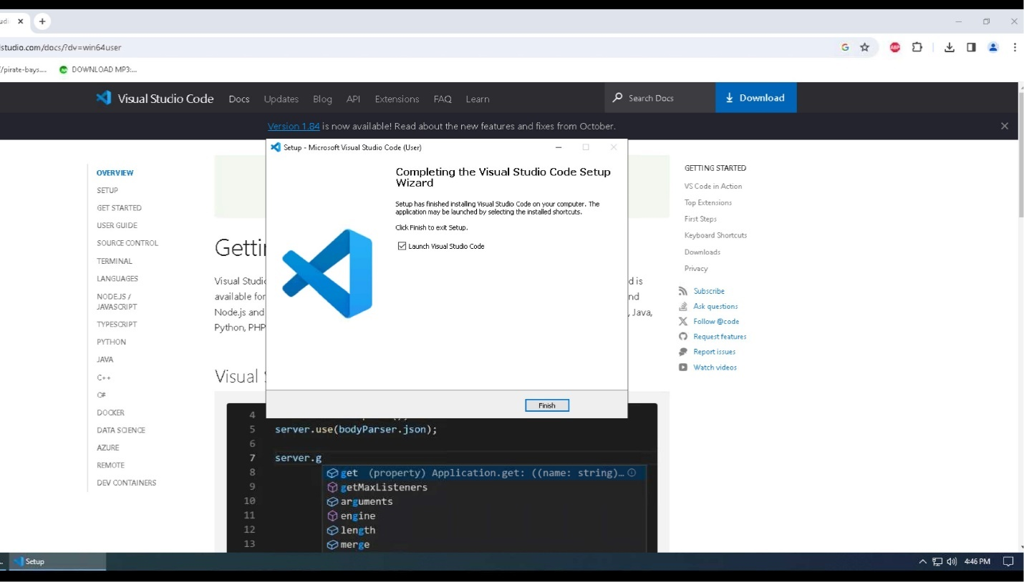

1. Visual Studio Code will now open. You will need to click on the “Extensions” icon 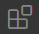 so the Python extension can be installed and write our Python code inside Visual Studio Code.

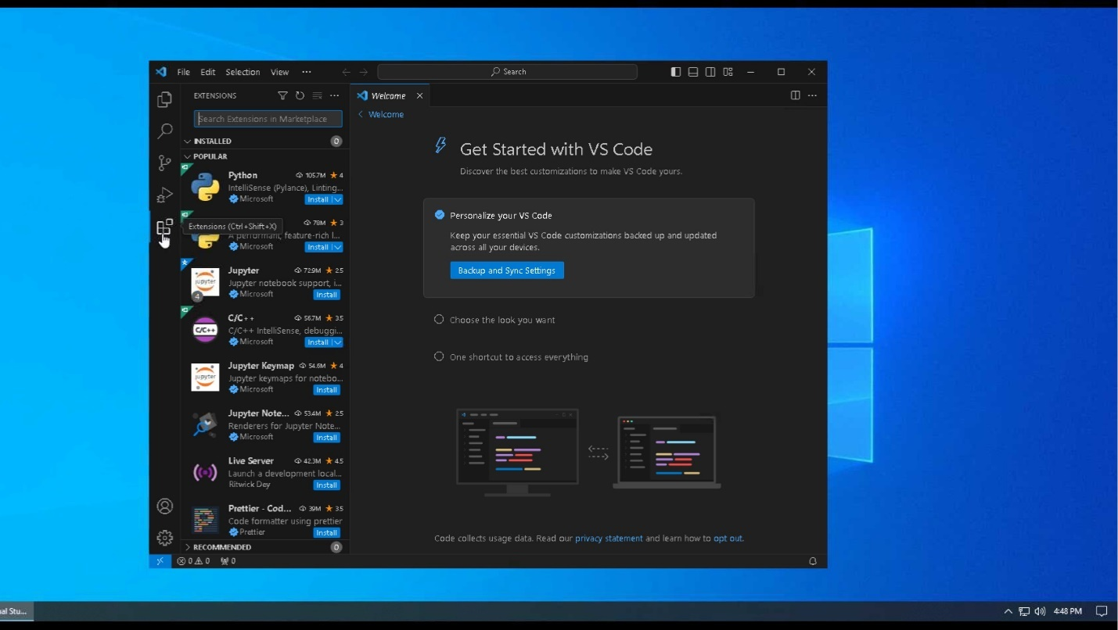

1. Click on “Install” under the Python Extension.

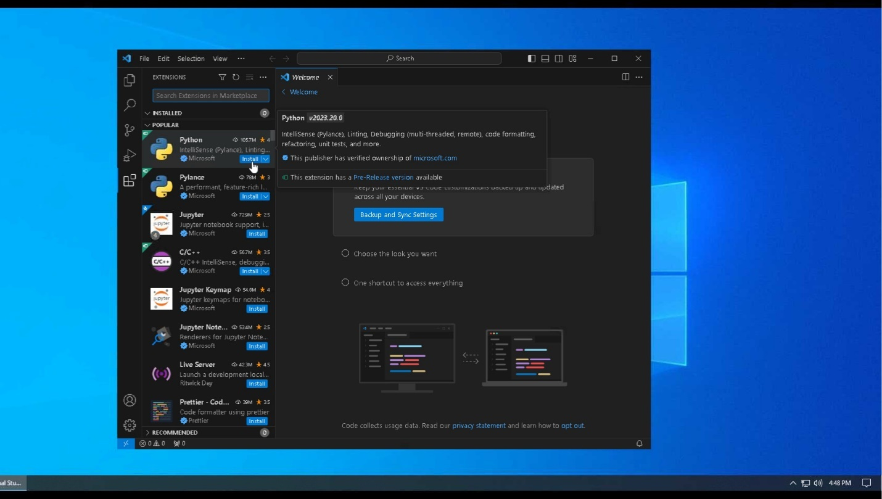

1. It will then install the Python extension. Once it is finished, you can write your Python code without receiving any errors.

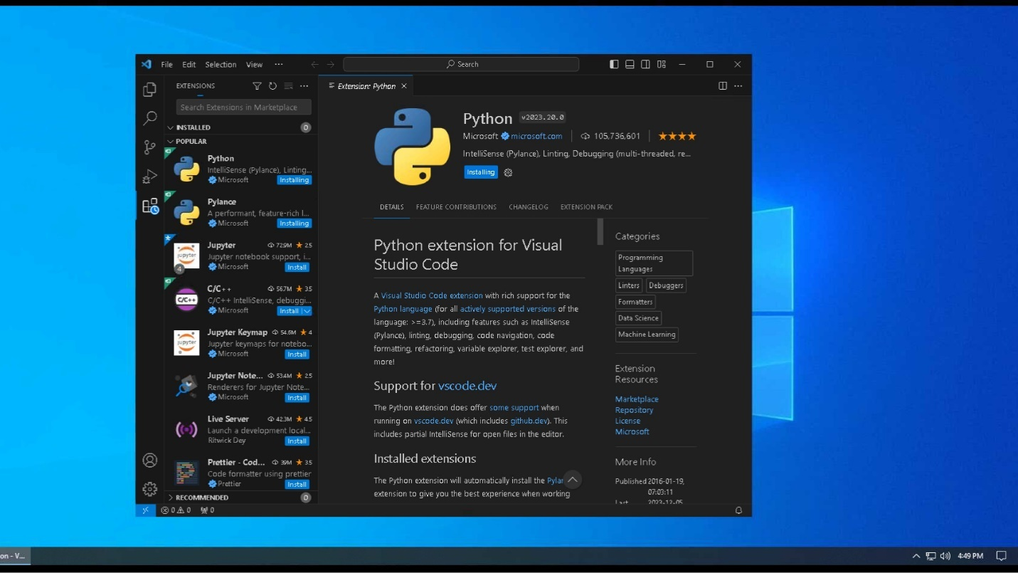

## **Download Website Code**

You will only need to choose one of the following methods to download the code

### **Clone GitHub Repository CSC289**

1. The first option will be to download the GitHub Desktop. You will go to the URL of <https://desktop.github.com> then click on “Download for Windows” button. This will download into your downloads folder.

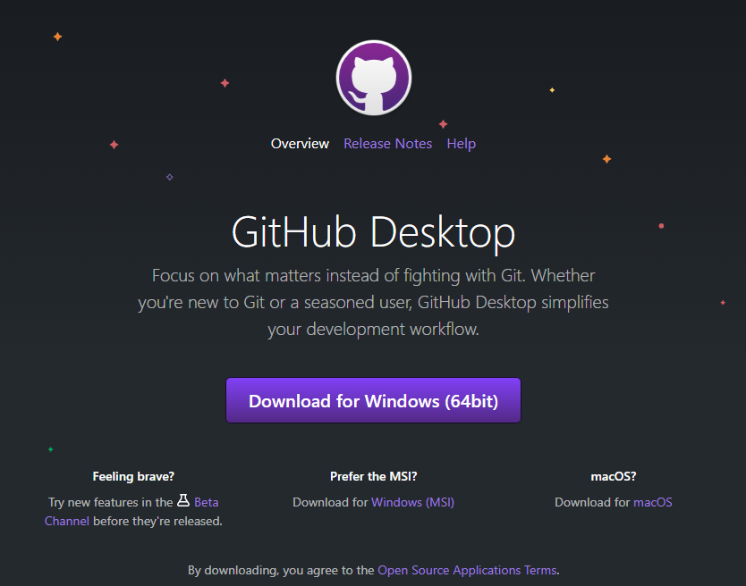

1. Go to your downloads folder and look for the GitHub Desktop Setup executable file and double-click it.



1. It will start to install onto your system and once it is complete, it will automatically open the GitHub Desktop program.

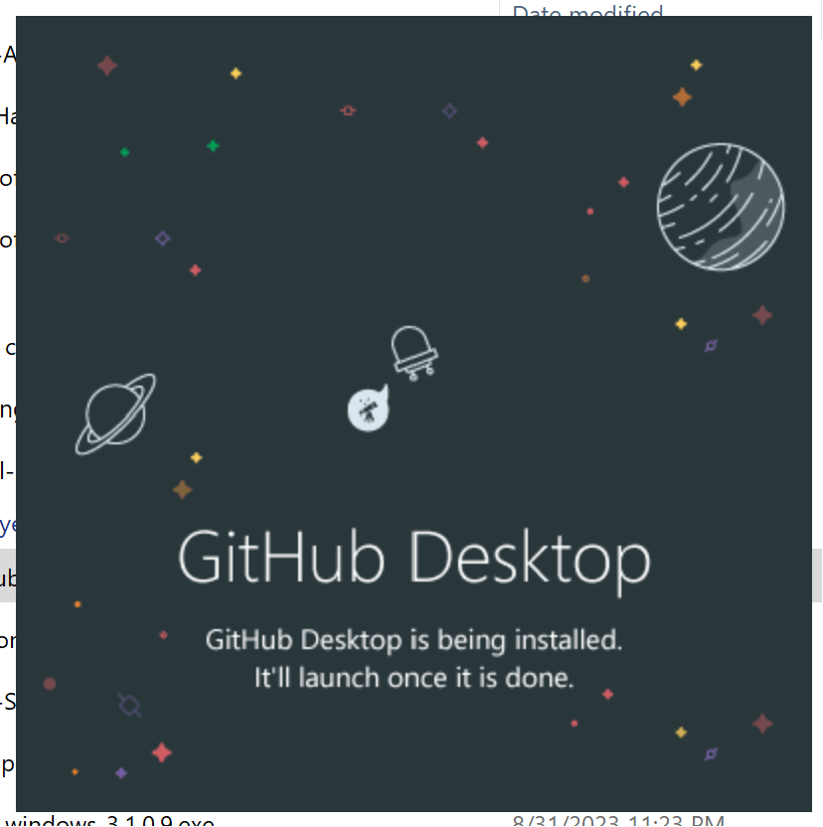

1. Click on “File”, then click “Clone Repository”. You will be able to download the repository you are looking for.

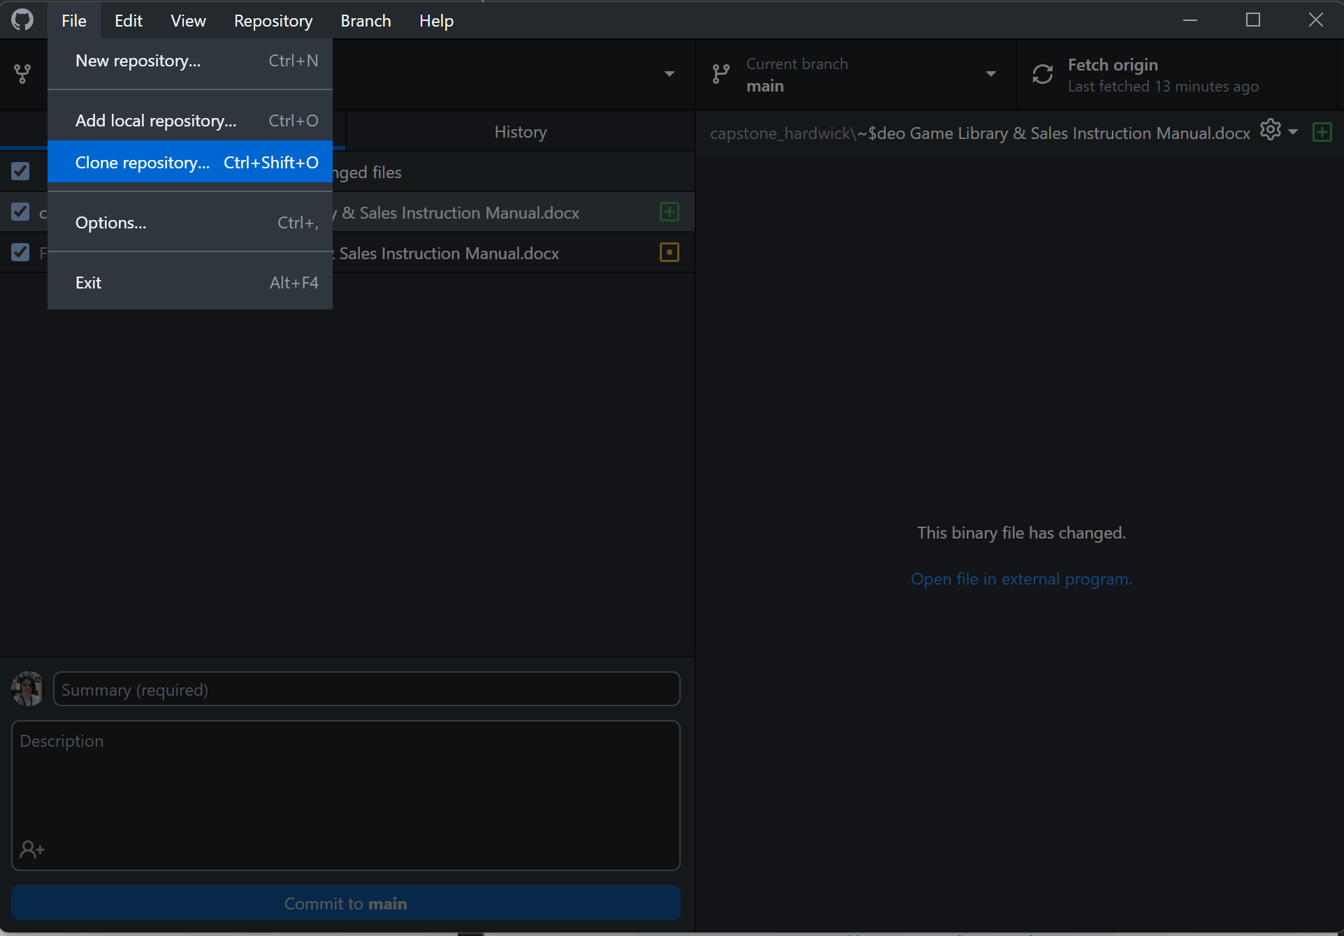

1. Select the repository you want to clone and then select the path you want to have the repository saved and click “Clone”.

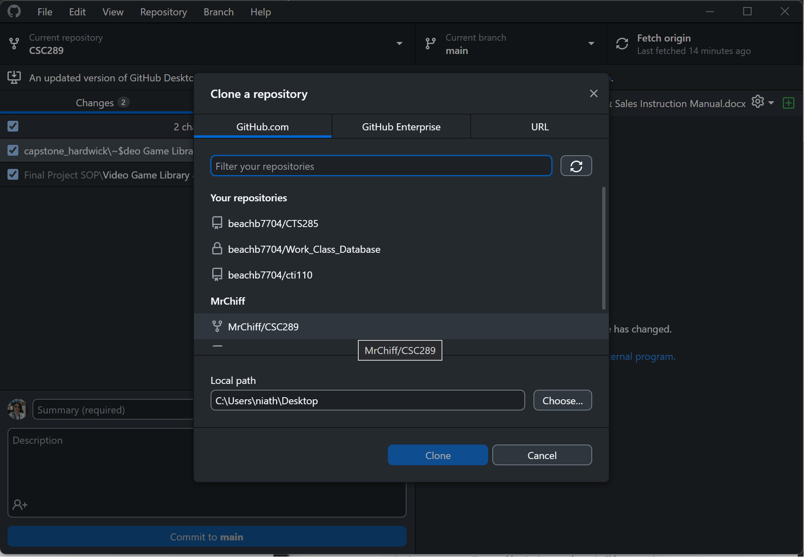

1. It will then start to download the repository to your system so you can have an offline version of your repository.

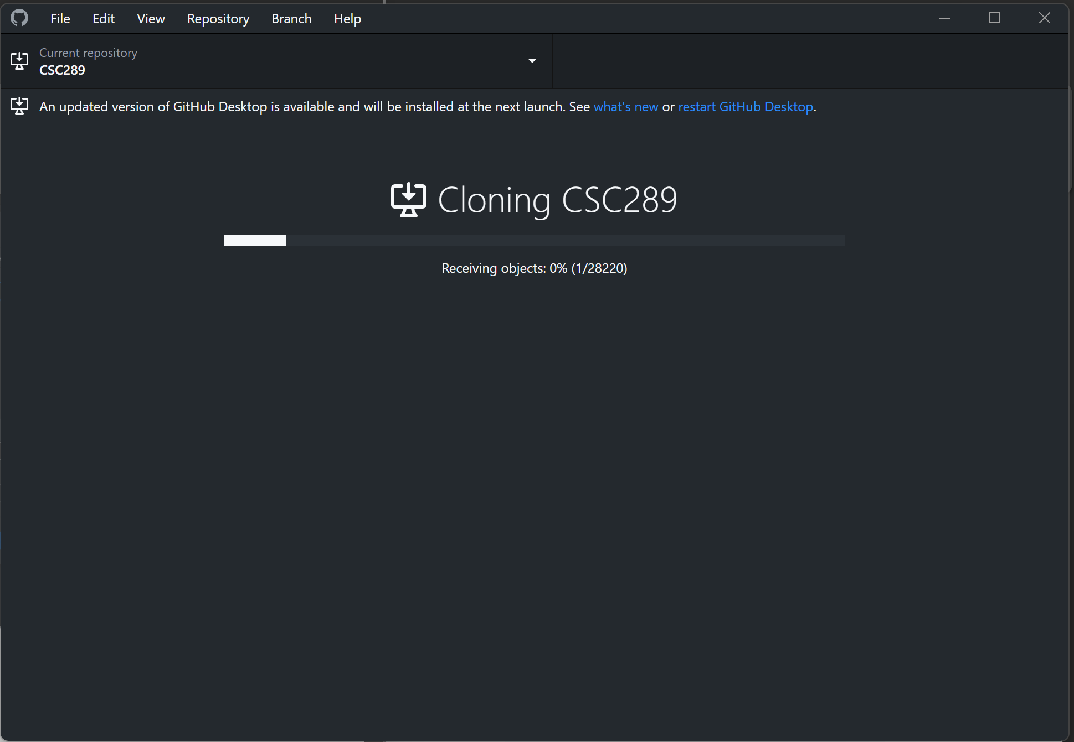

1. If you get a message asking you how you are planning to use this fork, just select for my own purposes, then click “Continue”.

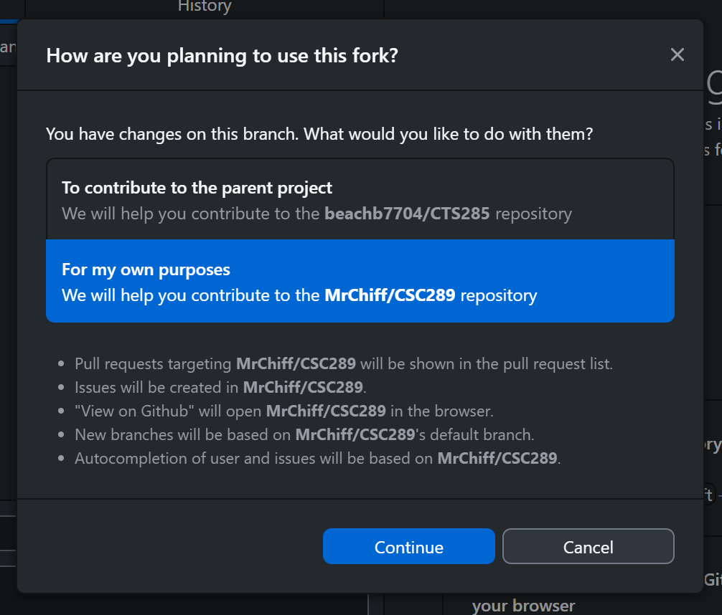

1. You have now downloaded your cloned repository and can now move on to opening the code inside Visual Studio Code.

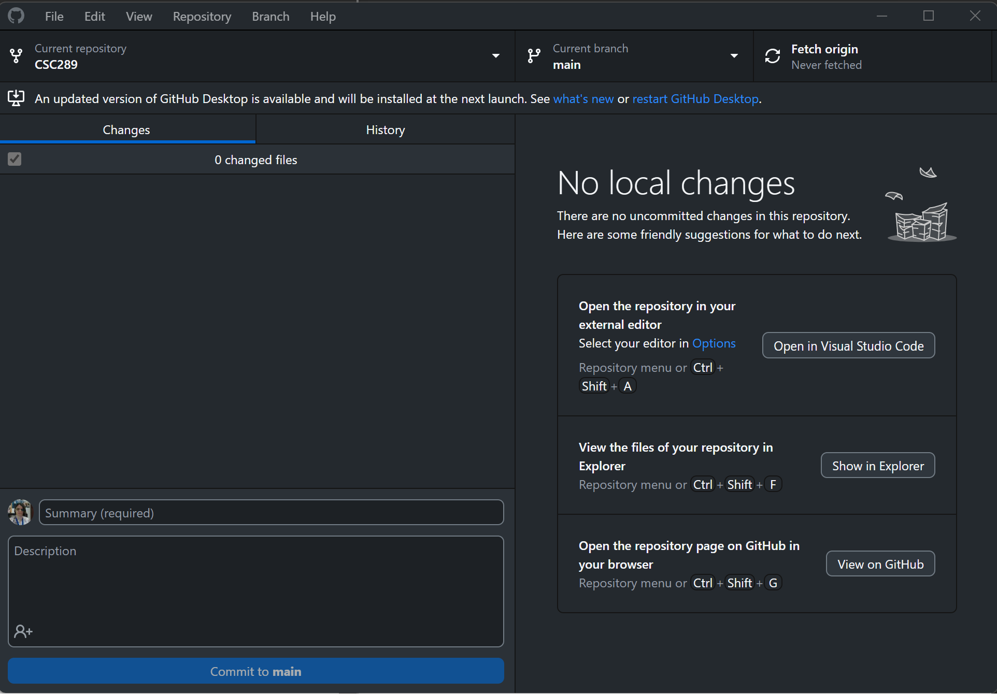

### **Download Website Code**

1. Go to the URL of <https://github.com/MrChiff/CSC289>.

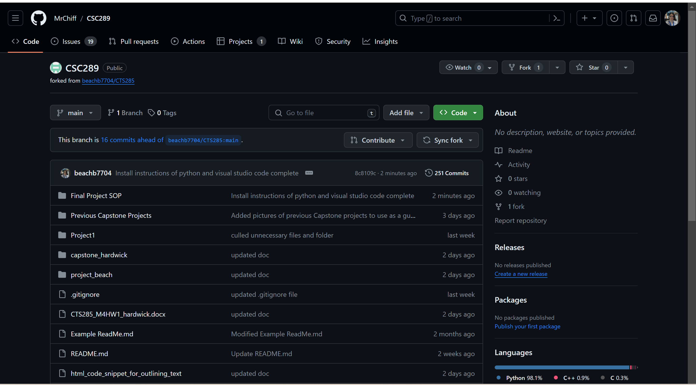

1. To download the code in a zipped file, click on the green button that says “<>Code” and then click on the Local Tab.

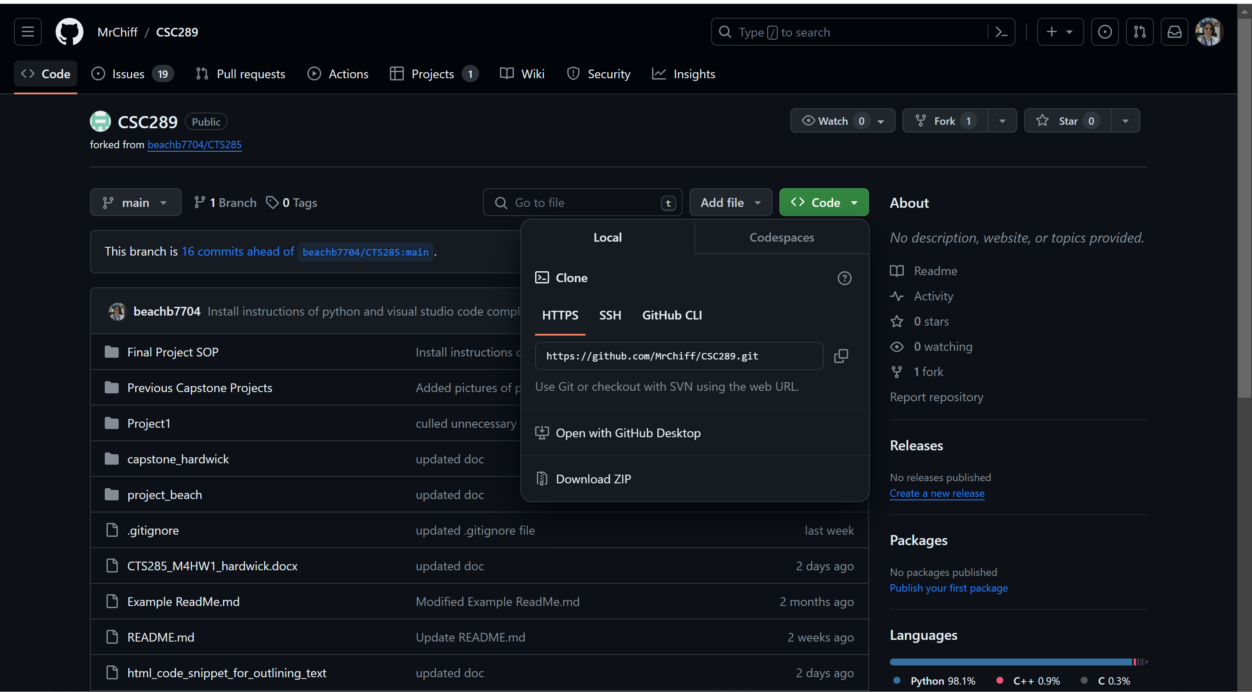

1. Click on Download ZIP, then select the location where you want the file downloaded if it brings up that option. If it does not, then it will download to your default folder for downloads.

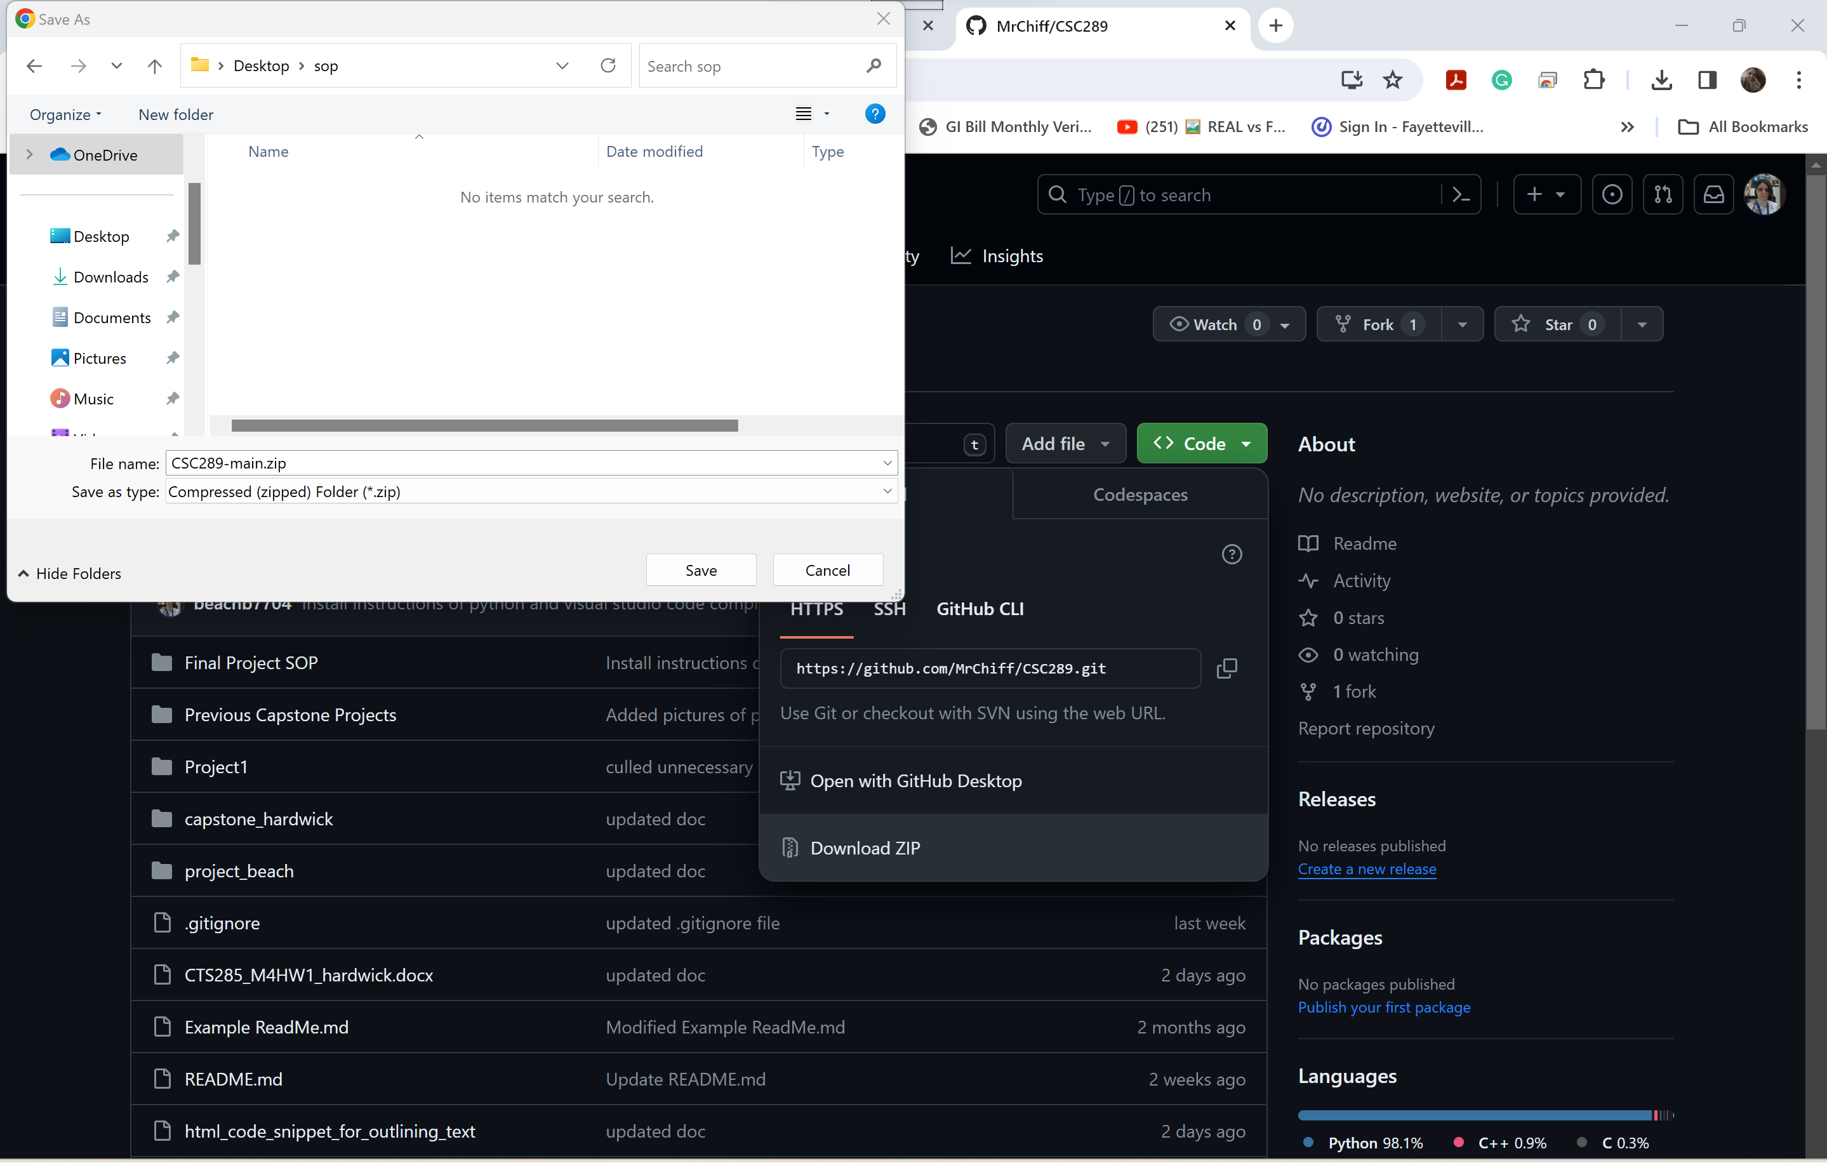

1. Open the folder to which you have saved the zipped file and right-click on it. Select Extract All so you can extract everything you have downloaded from GitHub.

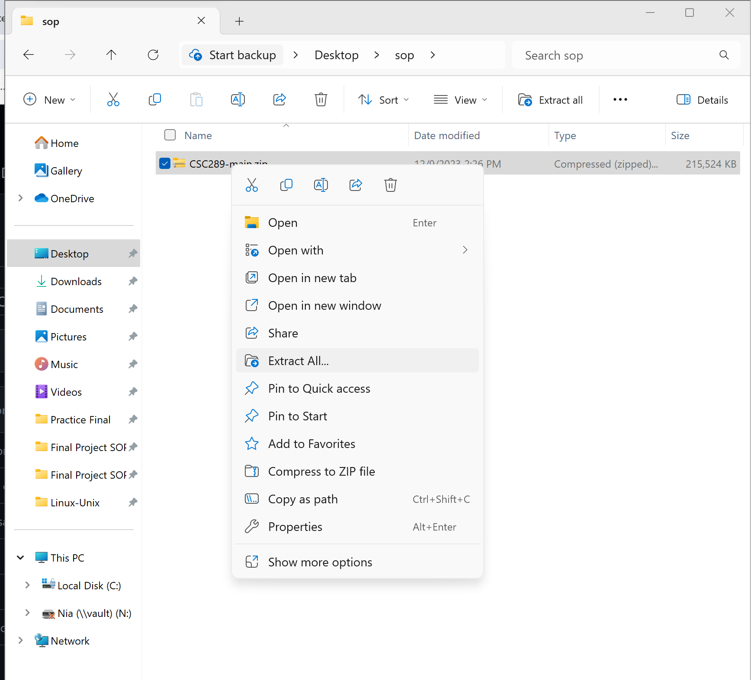

1. Select the folder to which you want to extract all the files, then click Extract.

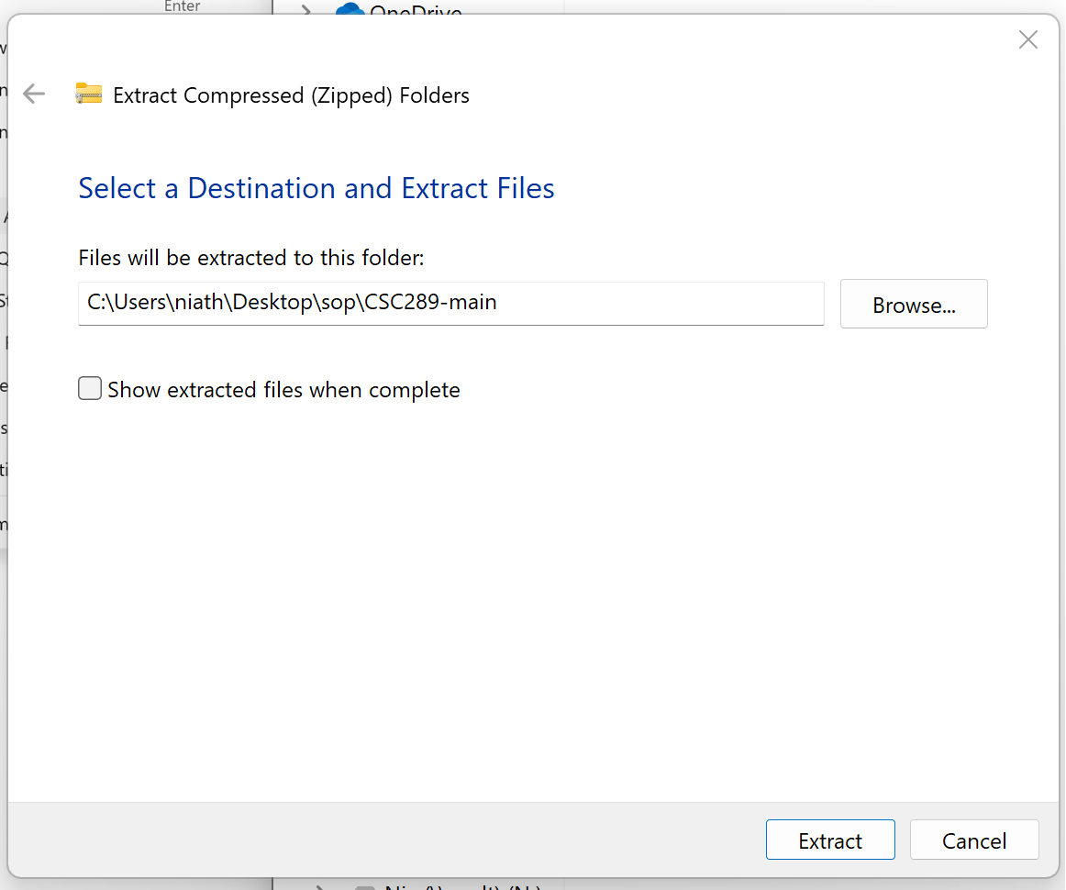

1. The files will now be extracted to that folder.

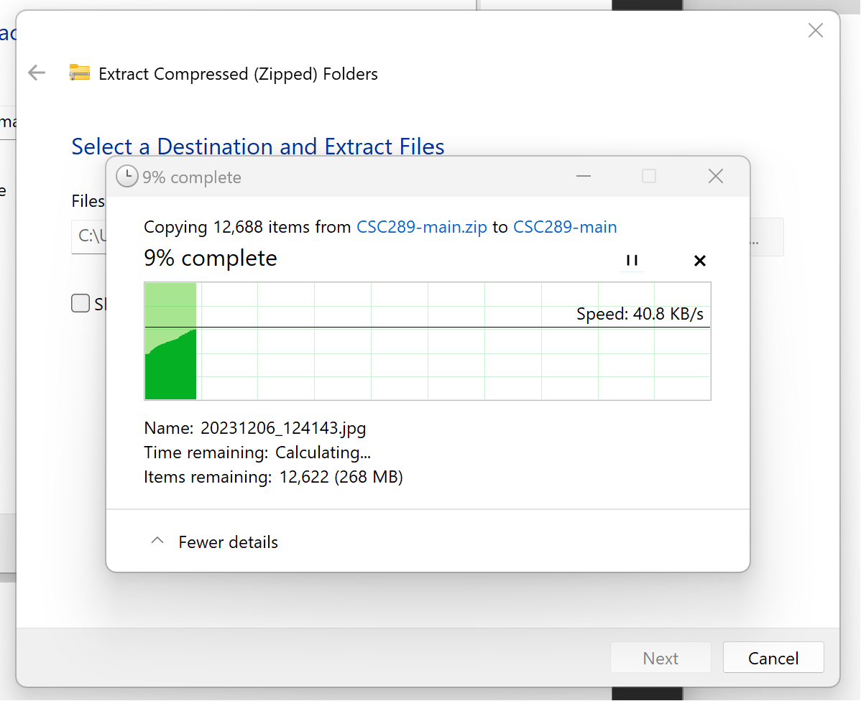

1. Once the files have been extracted, double-click on the new folder to open it and view the contents.

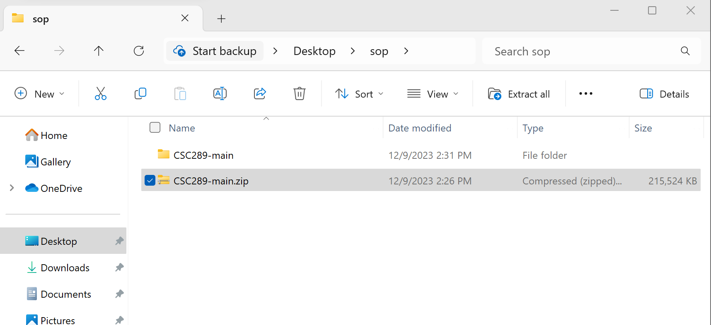

1. Double-click on the following folder to open it and view the contents.

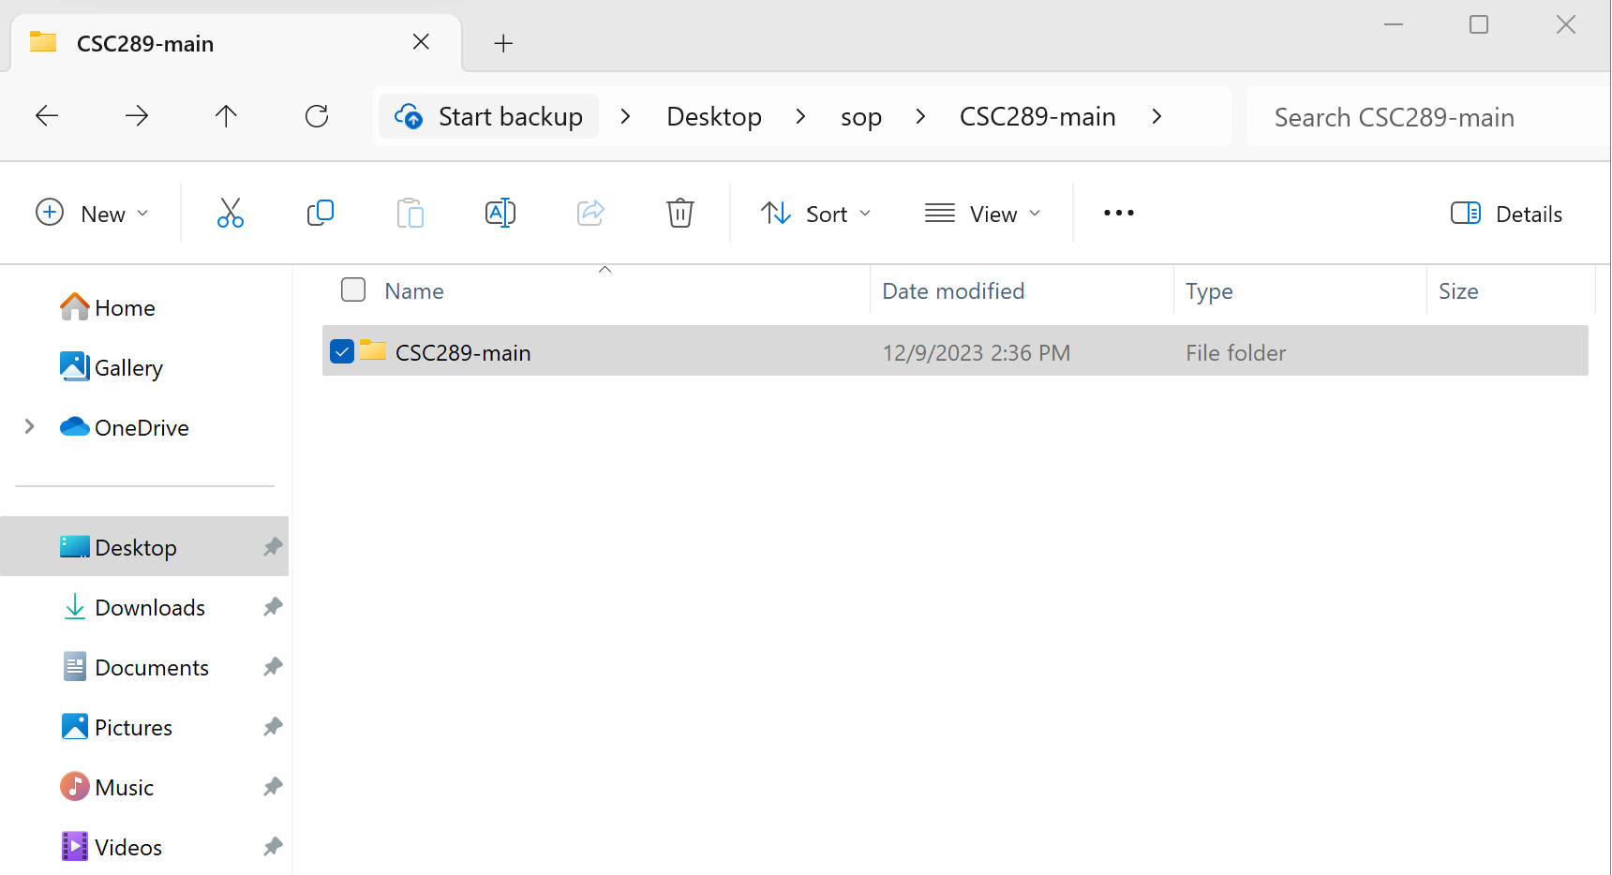

1. Now, you will verify that all files have been downloaded. Once verified, you can open the project inside Visual Studio Code and create your virtual environment.

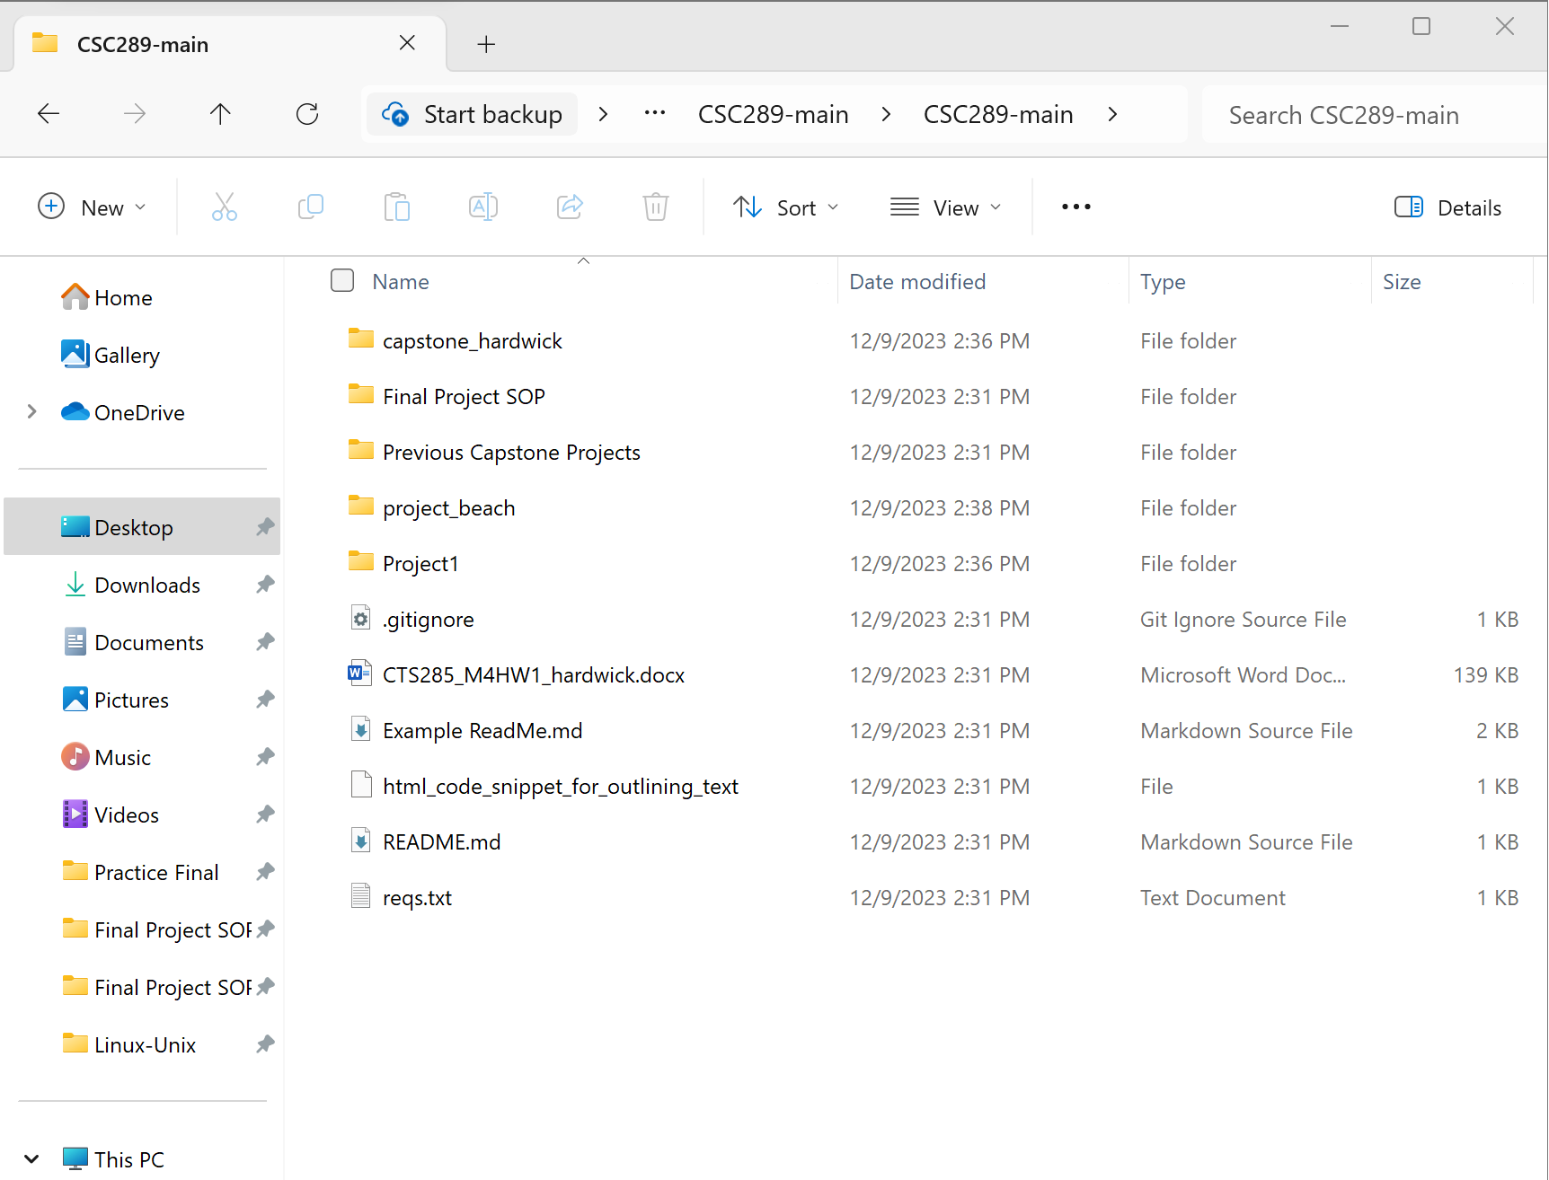

# **Open the Project in Visual Studio Code and Activate the Virtual Environment**

1. If you still have Visual Studio Code open from when you installed it, all you will need to do is click on File, then click on Open Folder.

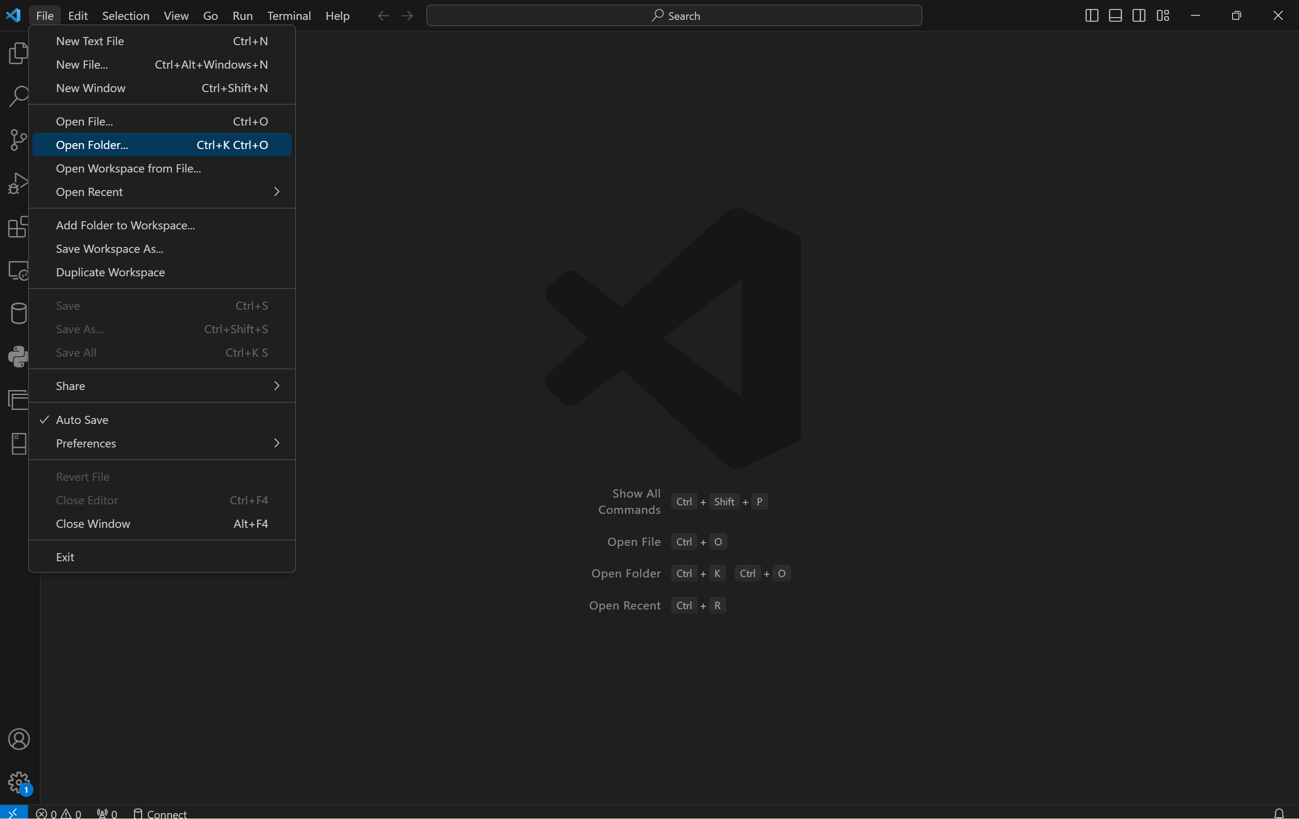

1. Navigate to the folder of the project you want to open. Only click on the main folder, then click on Select Folder.

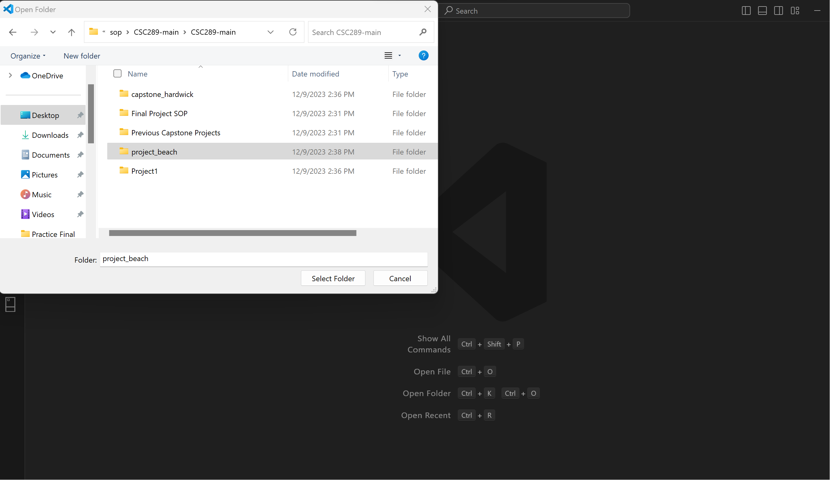

1. At the top of the screen, click Terminal, then New Terminal.

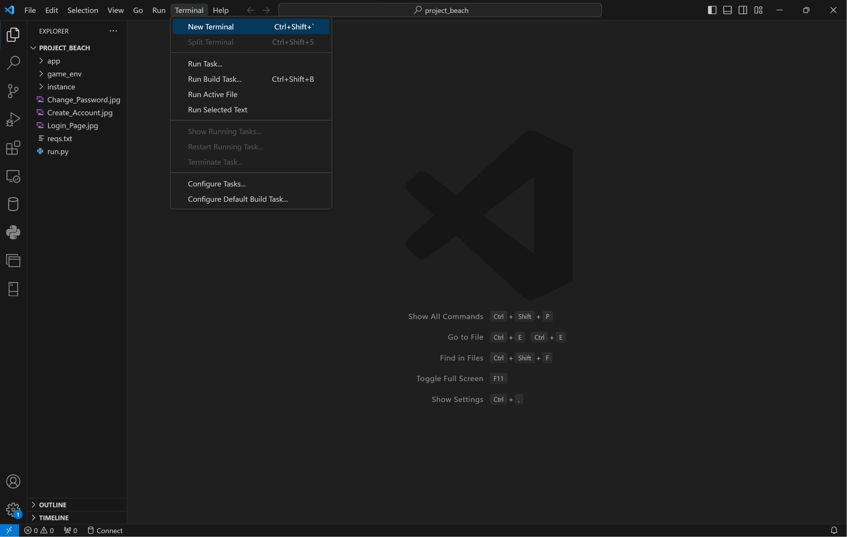

1. Click on the arrow by the plus symbol, then click on Command Prompt to open a command prompt where we will create our virtual environment.

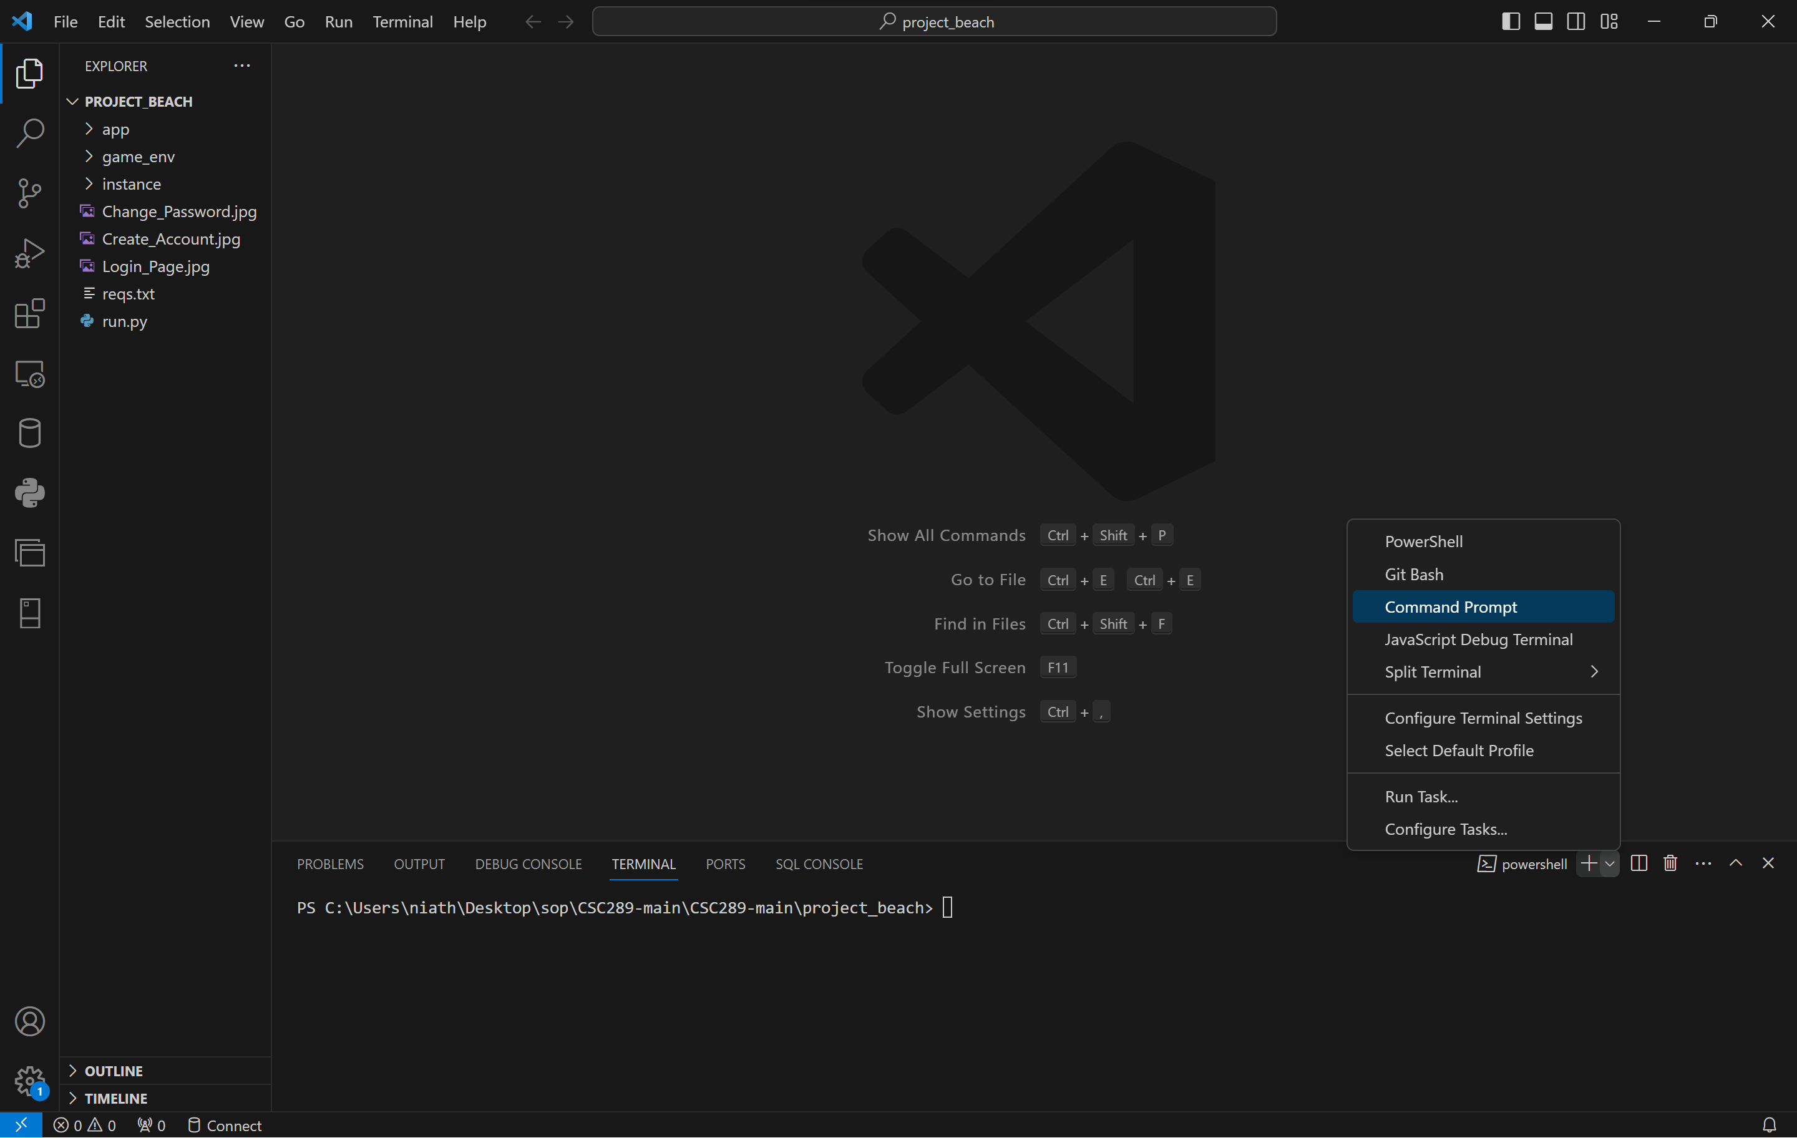

1. Now, we need to remove the Power Shell terminal by clicking on the trash can icon next to the Power Shell terminal.

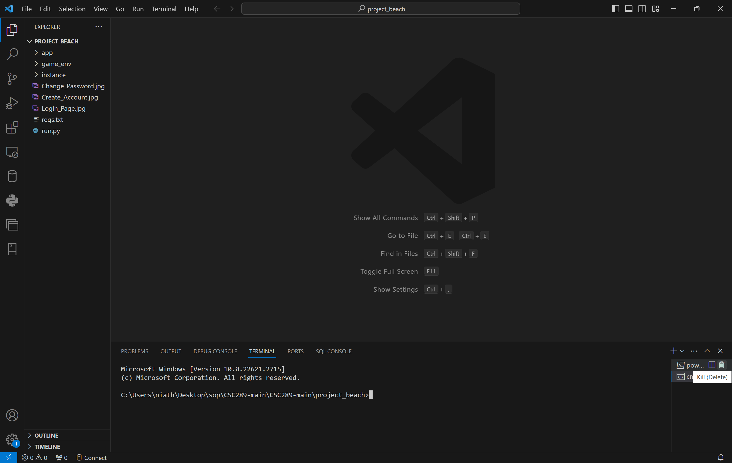

1. Use the command python -m virtualenv “your environment name.” An example would be:

python -m virtualenv vgls_env

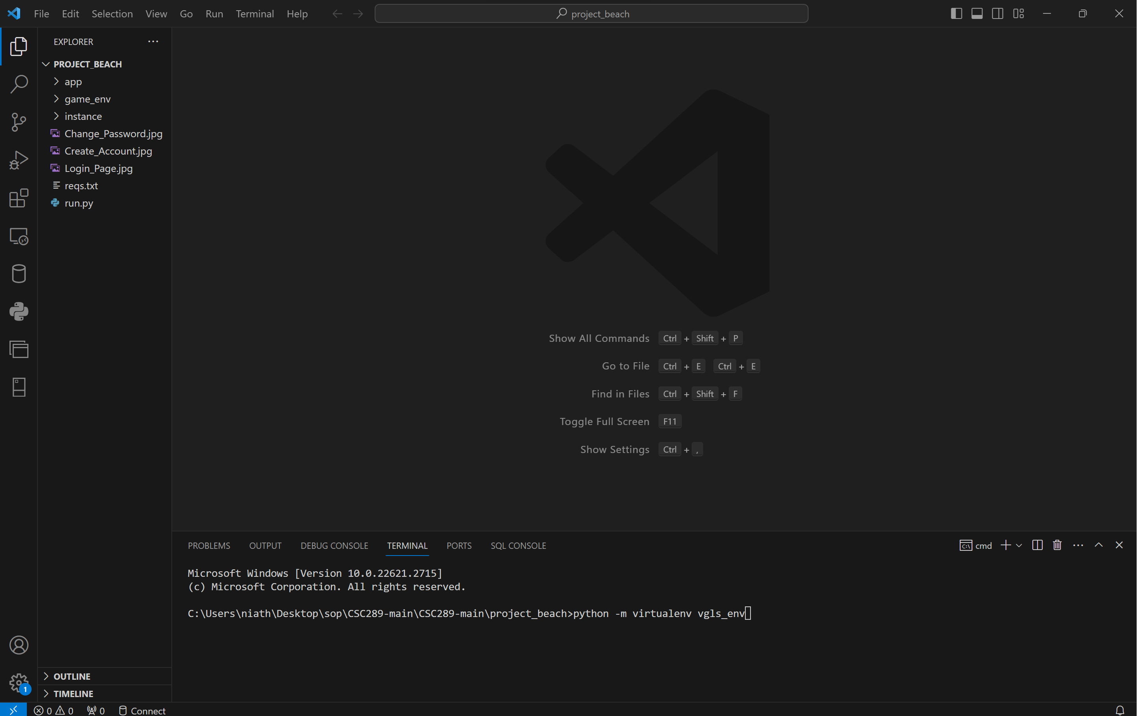

1. Once you press Enter, it will create the virtual environment, and the folder will populate on the left side of the screen.

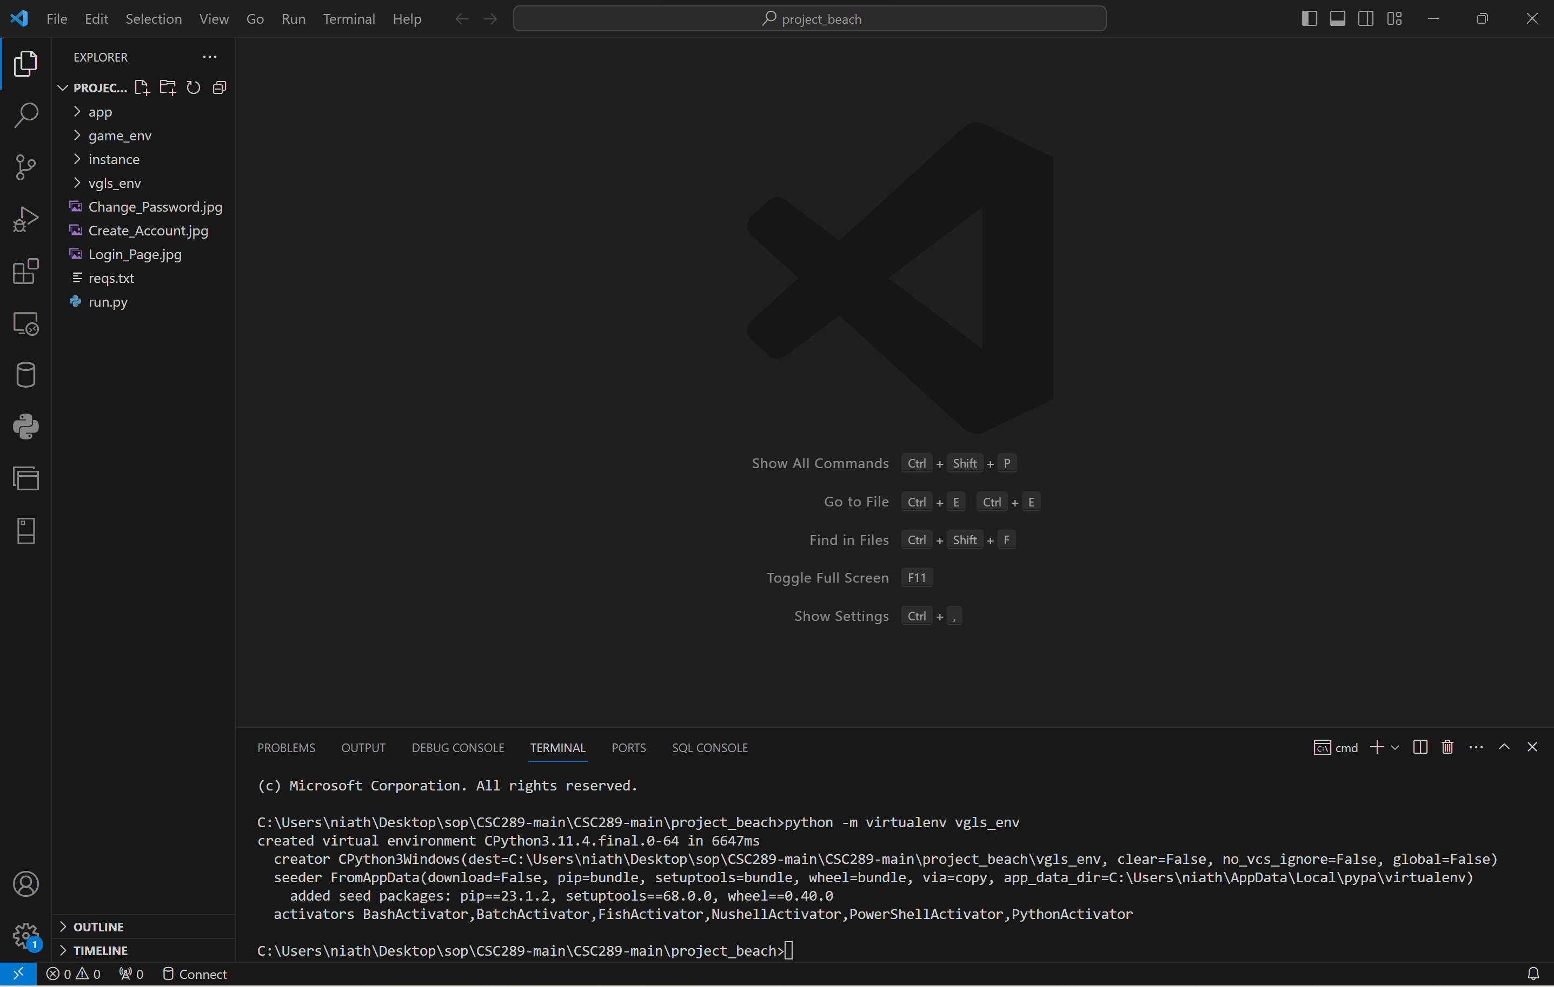

1. You must type “your environment name”\Scripts\Activate. An example would be:

Vgls_env\Scripts\Activate. You will then see the virtual environment name within these brackets(). This will let you know that you are now in your virtual environment.

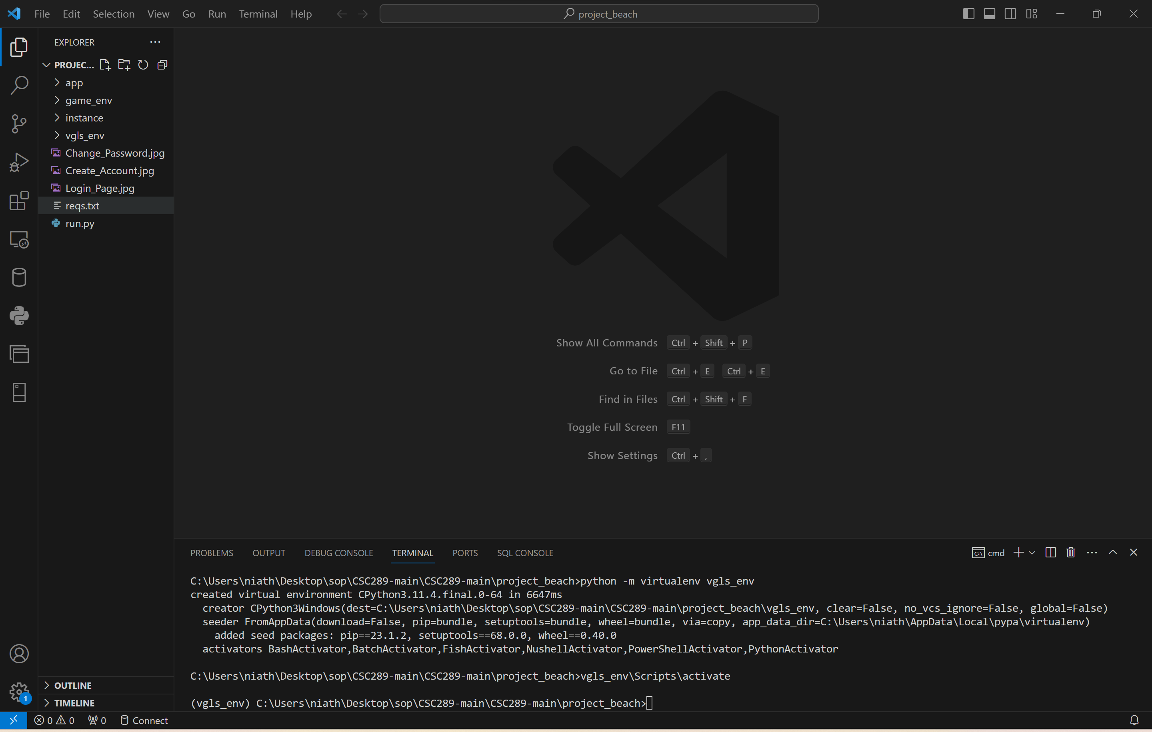

# **Install All Necessary Modules inside the Virtual Environment**

1. Type the following command pip install -r reqs.text. The reqs.text is the file name with all the modules required to run this program. You may get an error if a newer version of pip has been released.

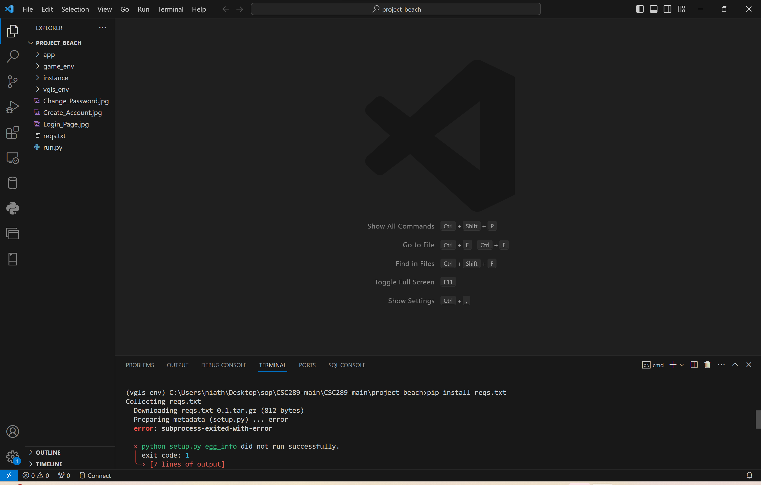

1. If you get an error, you will type the following command: python .exe -m pip install –upgrade pip. This will install the latest version of pip into your virtual machine. Then try again with the pip install -r reqs.txt to install all the needed files.

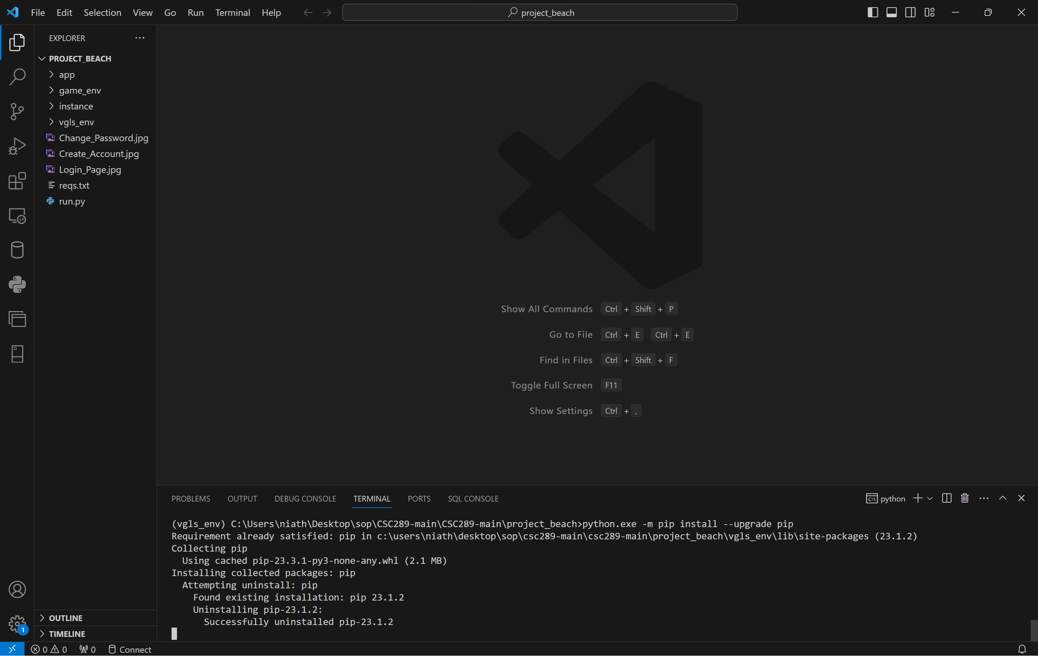

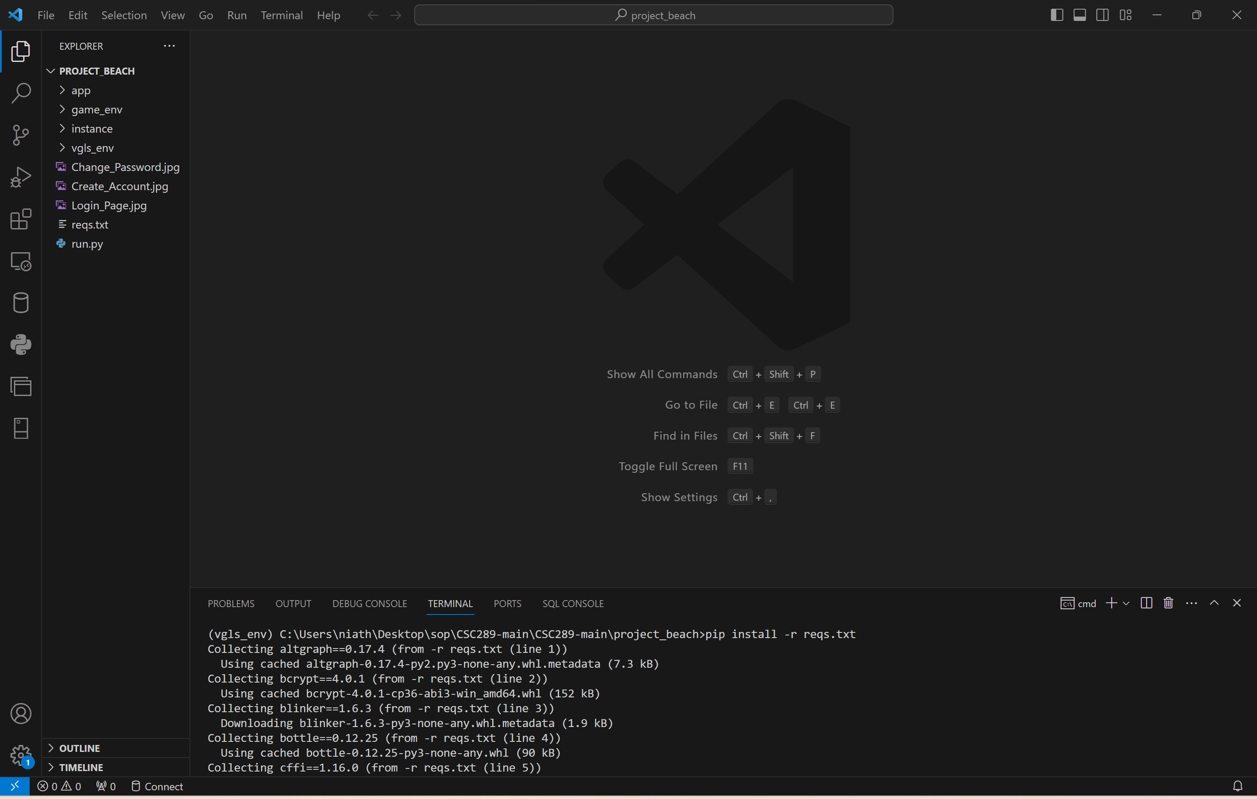

1. To verify that all of the files are downloaded, you will type pip freeze, then press the Enter key. It will then show all of the modules that are installed.

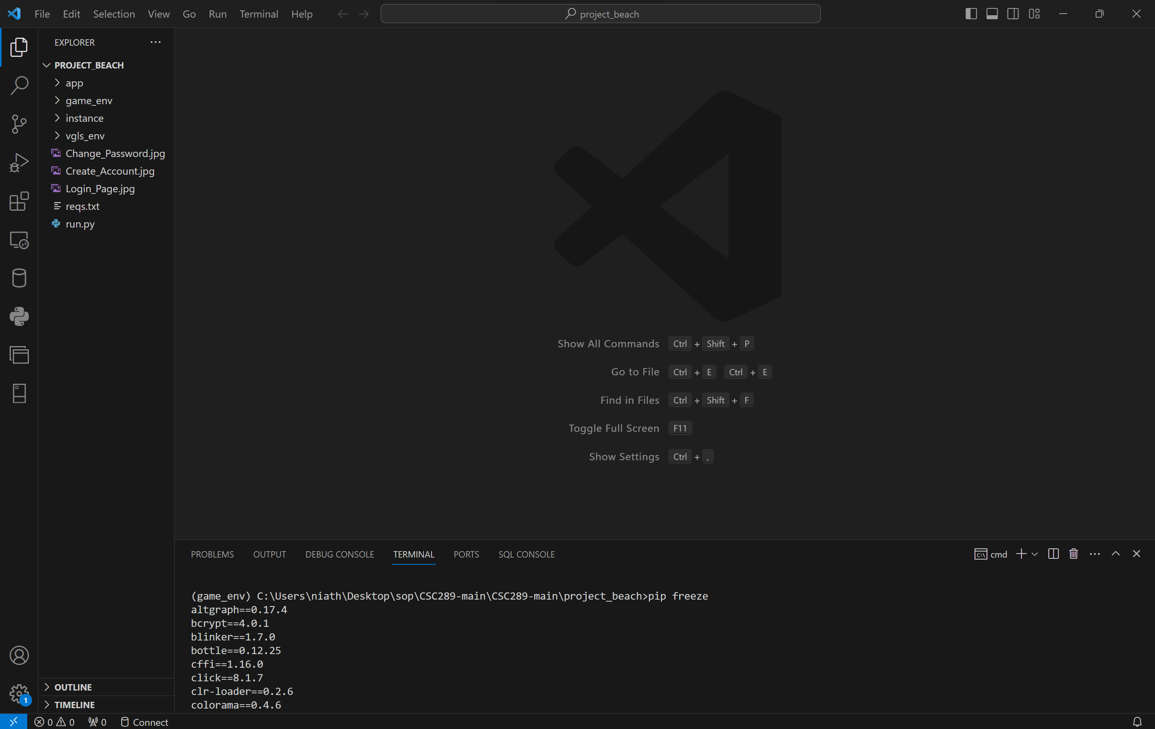

1. There are issues with the current version of the Werkzeug module. You will then need to uninstall the Werkzeug module and install a previous version, Werkzeug 2.3.7, by typing pip uninstall werkzeug. You will type y, then press the Enter key to verify you want to uninstall the module.

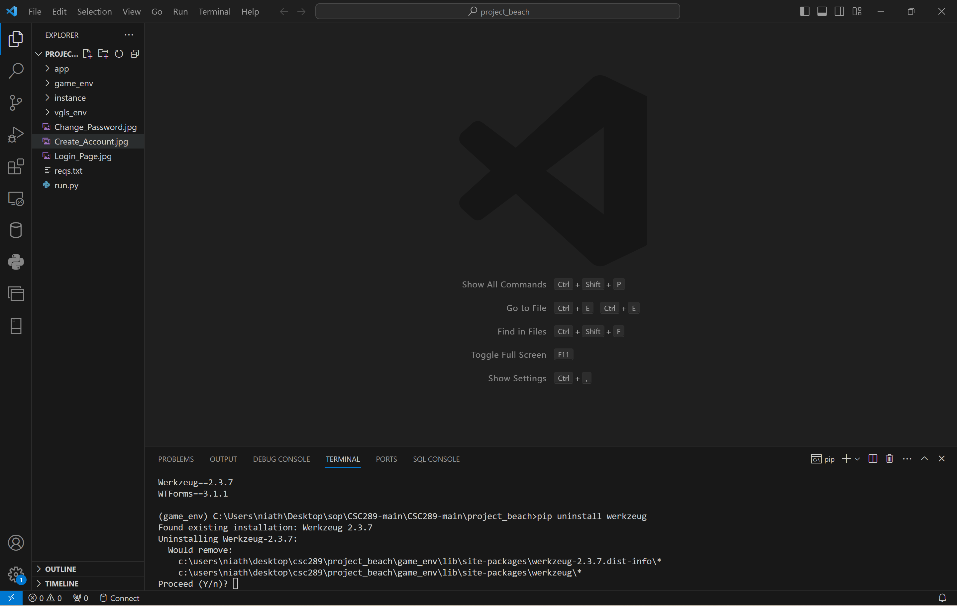

1. You will now need to install werkzeug version 2.3.7 by typing pip install werkzeug==2.3.7. It will then install Werkzeug version 2.3.7.

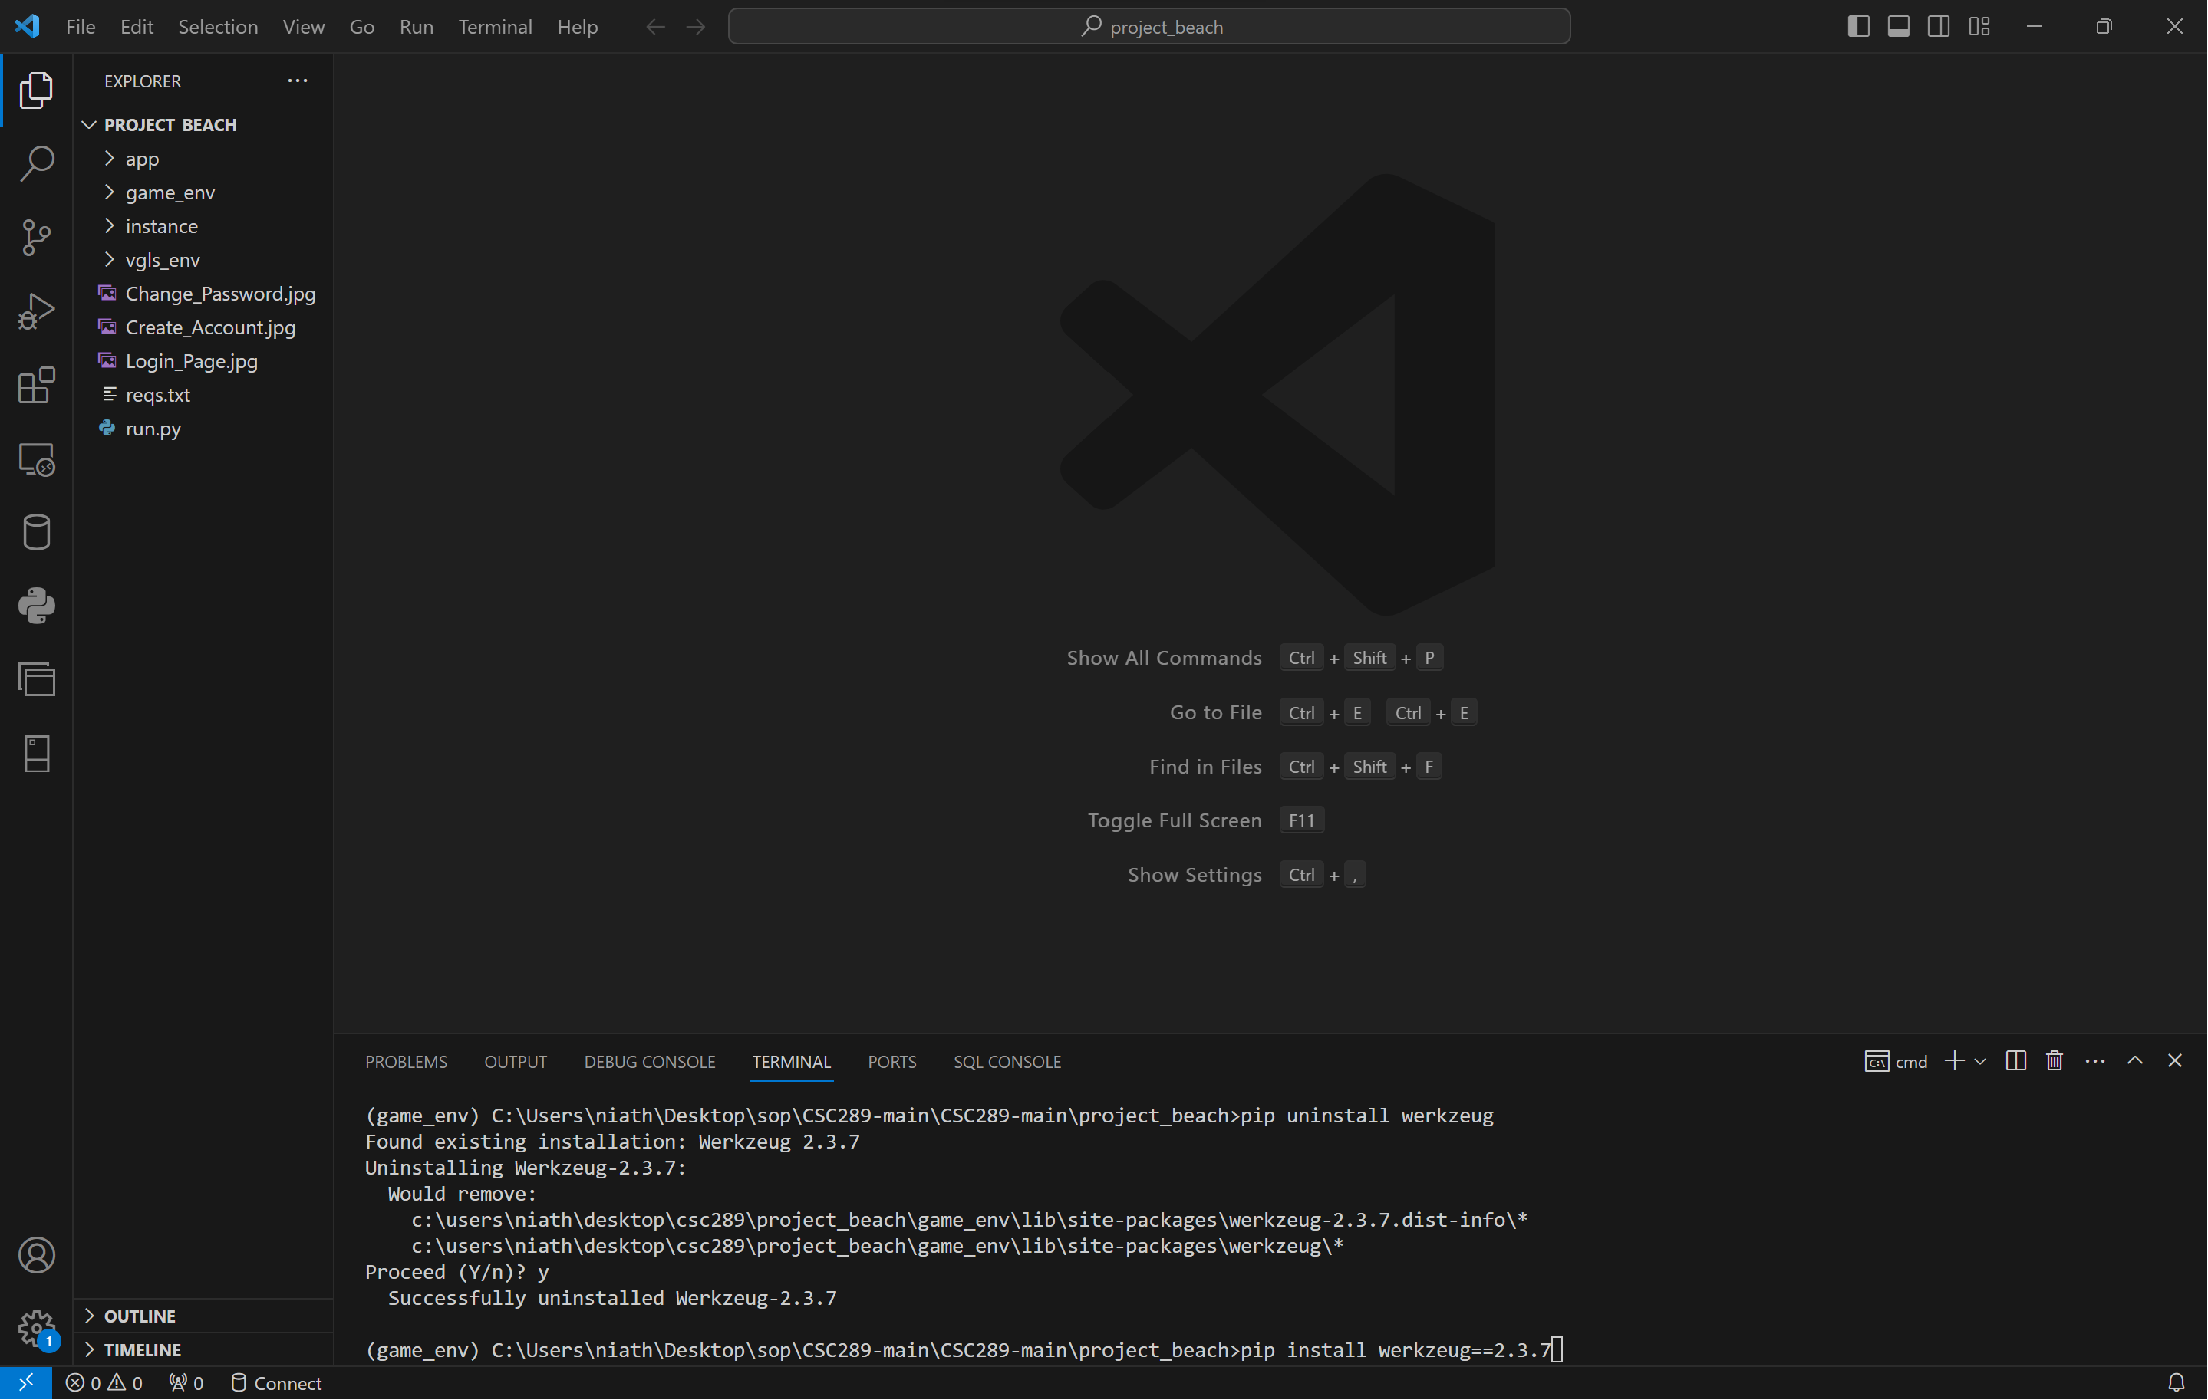

# **Initialize the Website**

1. Type the following command: python run.py to bring up the link you will click on to open a web browser.

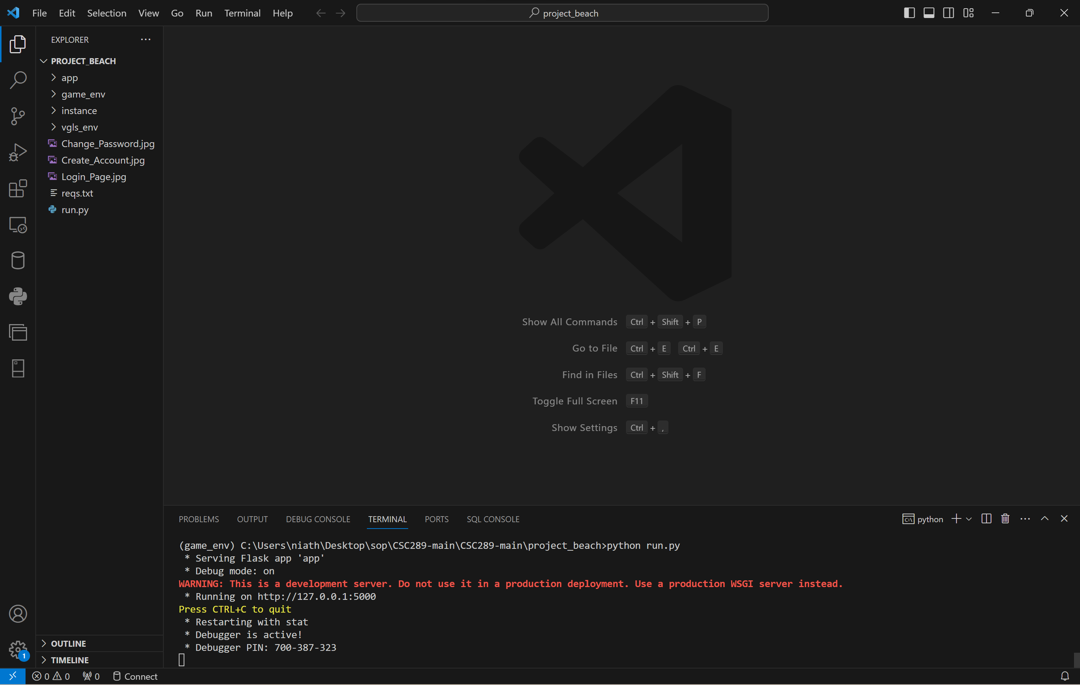

1. Press the Ctrl button and click on the IP address <http://127.0.0.1:5000>. It will then pull up the welcome page of the Video Game Library & Sales Website.

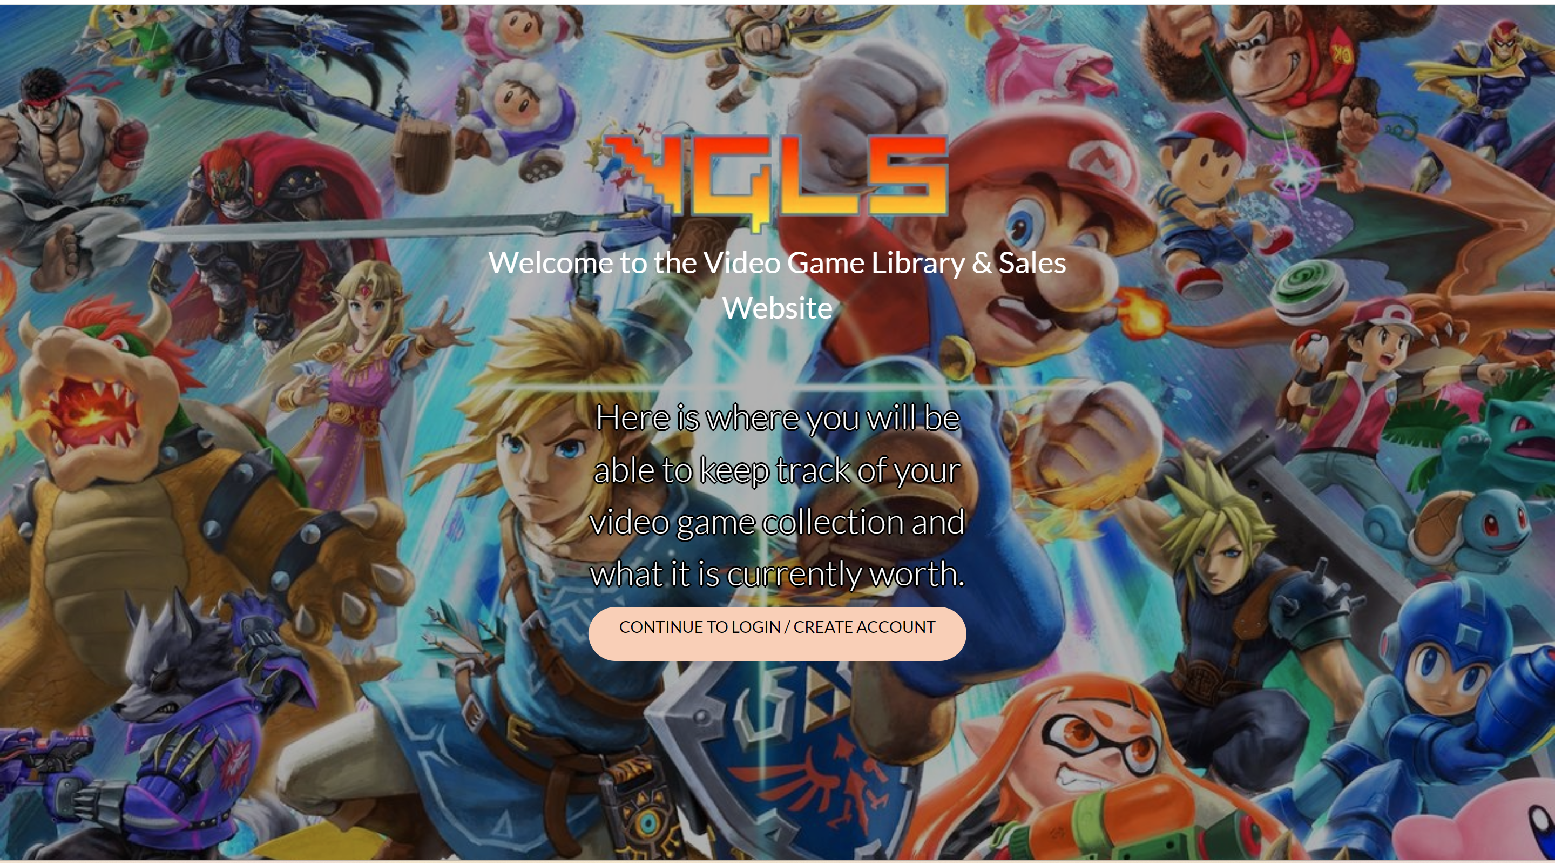

# **Using the Website**

In this section, we will cover how to use the website. The website will be fully searchable for users that do not have an account. If the user wants to build a library of their video games and possibly wants to sell them one day, they can create a video game/console/accessory library and add items to this library.

## **Website Registration**

1. To get to the Registration/Login page, you will click on “Continue to Login/Create Account” from the welcome page. It will then send you to the sign-in page. To create an account, you will click on the Create Account link.

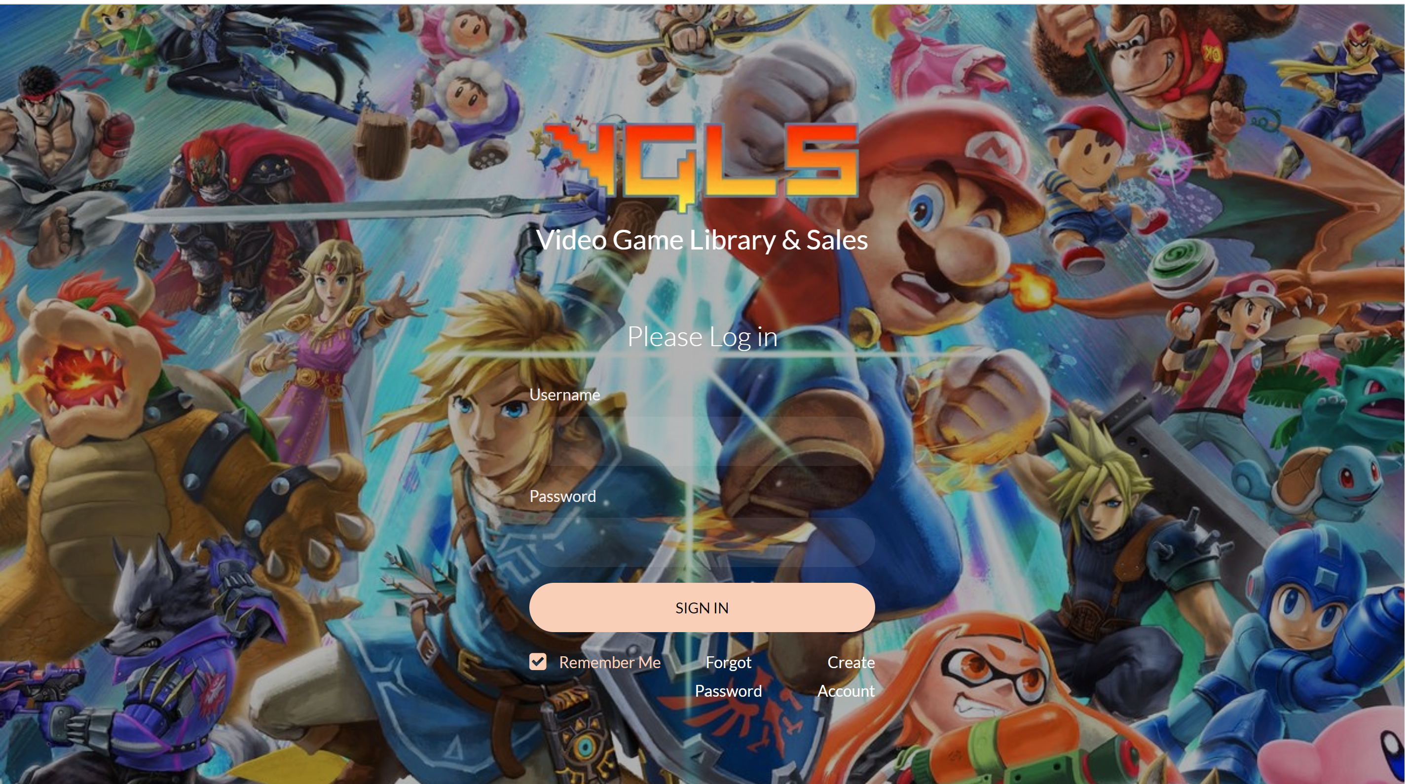



1. You will create a username and password and enter your first and last name. You will then click on Register Account. It will accept your input if the username is not used and redirect you to the login page. You will get an error message to select a new username if the username already exists.

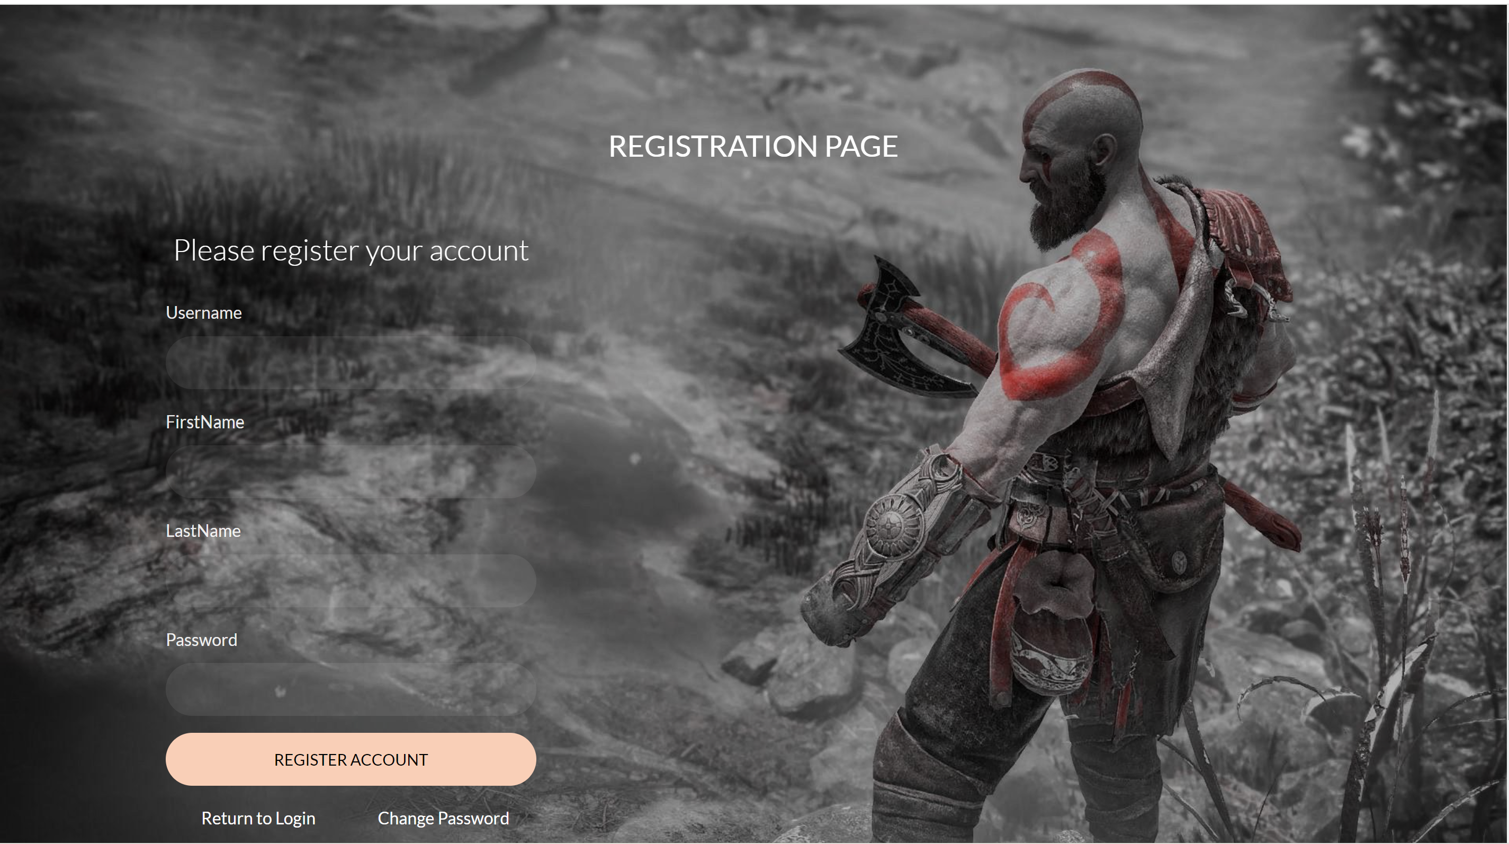

## **Password Reset**

1. Click on the Forgot Password link to get to the Change Password screen. It will then send you to the Change Password page.



1. If you forgot your password to log in, click on Change Password from the login Screen. You can input your username, type in your new password, and click Change Password. If the username exists, then you can change your password. If the username does not exist, you will get an error message.

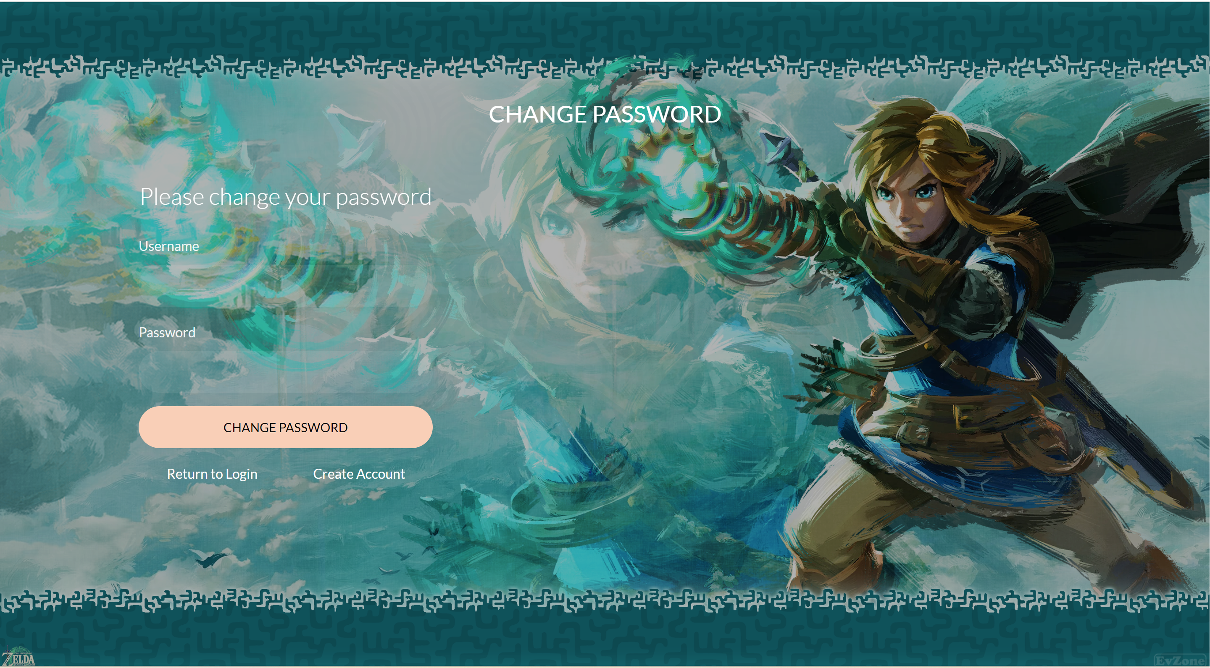

## **Login to the Website**

1. To log into the website, input your username and password and click Sign In.



1. If your username and password are correct, it will then log you in and take you to the home screen. This webpage is currently under construction.

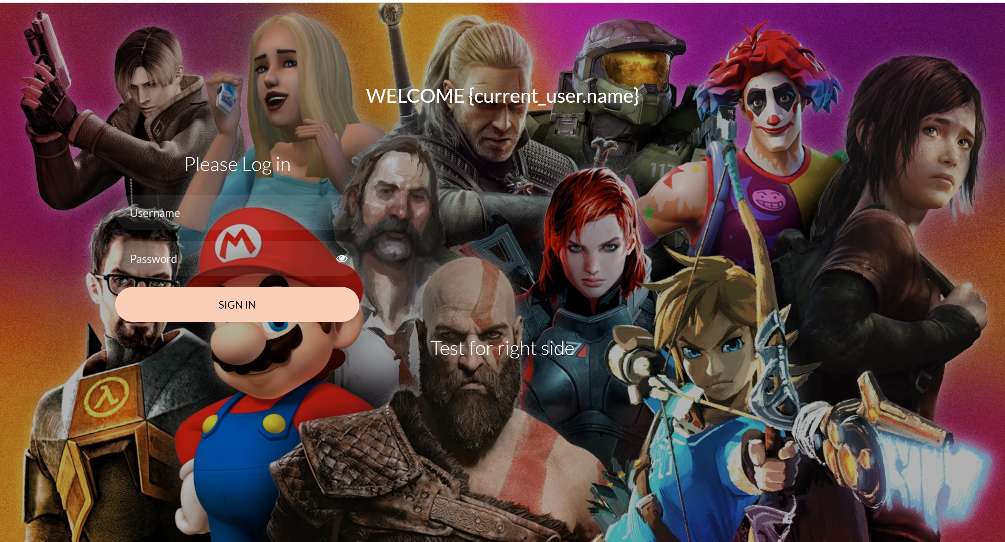

## **Select/Search for Specific Video Game**

1. To search for a specific video game/console/accessory, you will click inside the search box, and type your selection. Then you will click on “Search”, and it start the search to look for that selection.

**Place search page screenshot here**

1. Once the selection is found, it will show details of what you selected. If you typed in a video game, it will show what the game is about.

**Place Results of search screenshot here**

1. On the home page, there are also buttons where you can select a desired category. (Video games/console/accessories). Click on your desired category button. For this manual, we will select video games.

**Place Home page screen shot here with the buttons outlines to show where to click**

1. Depending on the category button you clicked, it will display an alphabetized list of games/consoles/accessories so you can find your desired item. Since we selected Video Games, it will show a list of video games in alphabetical order.

**Place Alphabetical video games list screenshot here.**

## **Creating a Video Game List on Account to Track Personal Collection**

1. To view your individual library, click on “Library” in the navbar, and it will check to see if you are logged in. If not, then it will let you know you need to be logged in before you can access the account section.

**Place Home screen screenshot here with the library navbar circled here.**

2. If you wanted to create a library of the video games/consoles/accessories you have, you can do so here. Only 1 of each item can be added to the main library of the program, however many users can have the name of that one game on their own library.

**Place Library for individual account screen shot here**

# **Admin Portal**

1. To access the admin portal, click the “Admin” link in the navigation bar. The program will then check to see if you have been authorized as an administrator.

**Place Home screen with Admin link in navigation bar highlighted screenshot here**

2. If the account has been authorized as an admin account; you will see the administrator page. Here, you can make changes to the database, add others as an administrator, and add additional items to the database so the users can add that to their individual libraries.

**Place Admin page screenshot here**